BOILING POINT (INITIAL): | 190-208°C | SPECIFIC GRAVITY: | 0.77 typical at 21°C
SOLUBILITY IN WATER: | Insoluble | pH: | Not Applicable
VAPOR PRESSURE:  PERCENT VOLATILE: | Not determined  Not determined | VAPOR DENSITY: | Not determined
VAPOR PRESSURE:  PERCENT VOLATILE: | Not determined  Not determined | VOC: | Not determined
COEFFICIENT OF WATER/OIL DISTRIBUTION: | Not Determined | APPEARANCE/ODOR: | Colorless liquid with a pleasant odor
FLASHPOINT: | 62°C | FLAMMABLE LIMITS: | LEL 0.7% UEL 6.0%
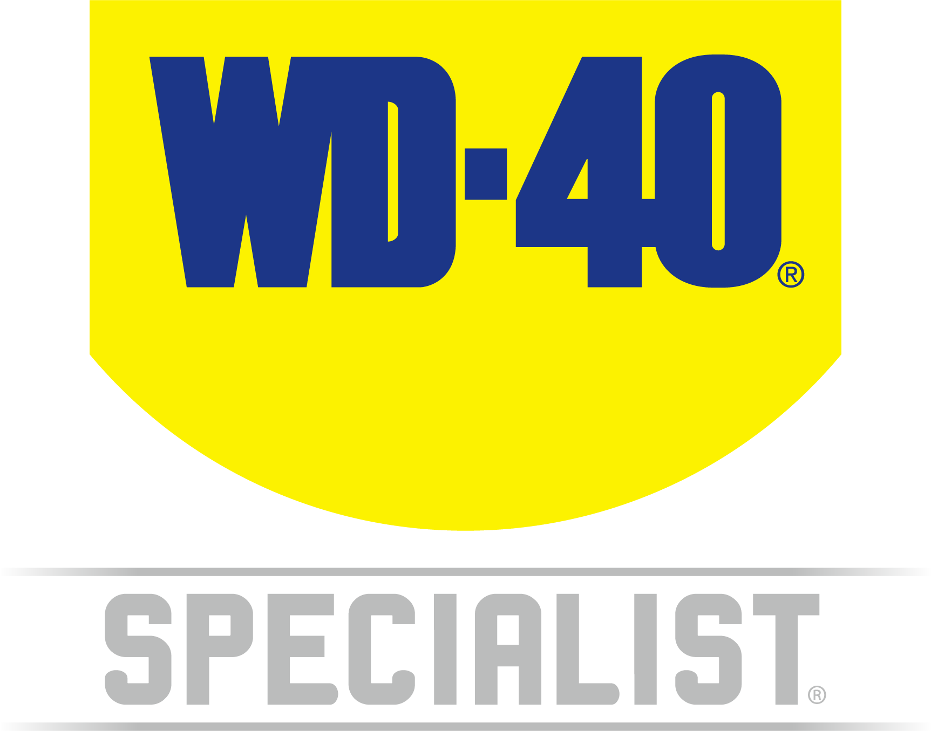

TECHNICAL DATA SHEET

WD-40 Specialist®
Silicone

Product Description |  | PACKAGING
WD-40 Specialist Silicone Lubricant waterproofs, lubricates and protects metal and non-metal surfaces such as rubber, plastic and vinyl. This formula leaves a clear, non-staining film which provides lubrication, won't attract dirt, and protects against moisture. It stops parts from sticking and can be used on application with plastic components. Effective in temperatures ranging from -40°C to +200°C. |  | 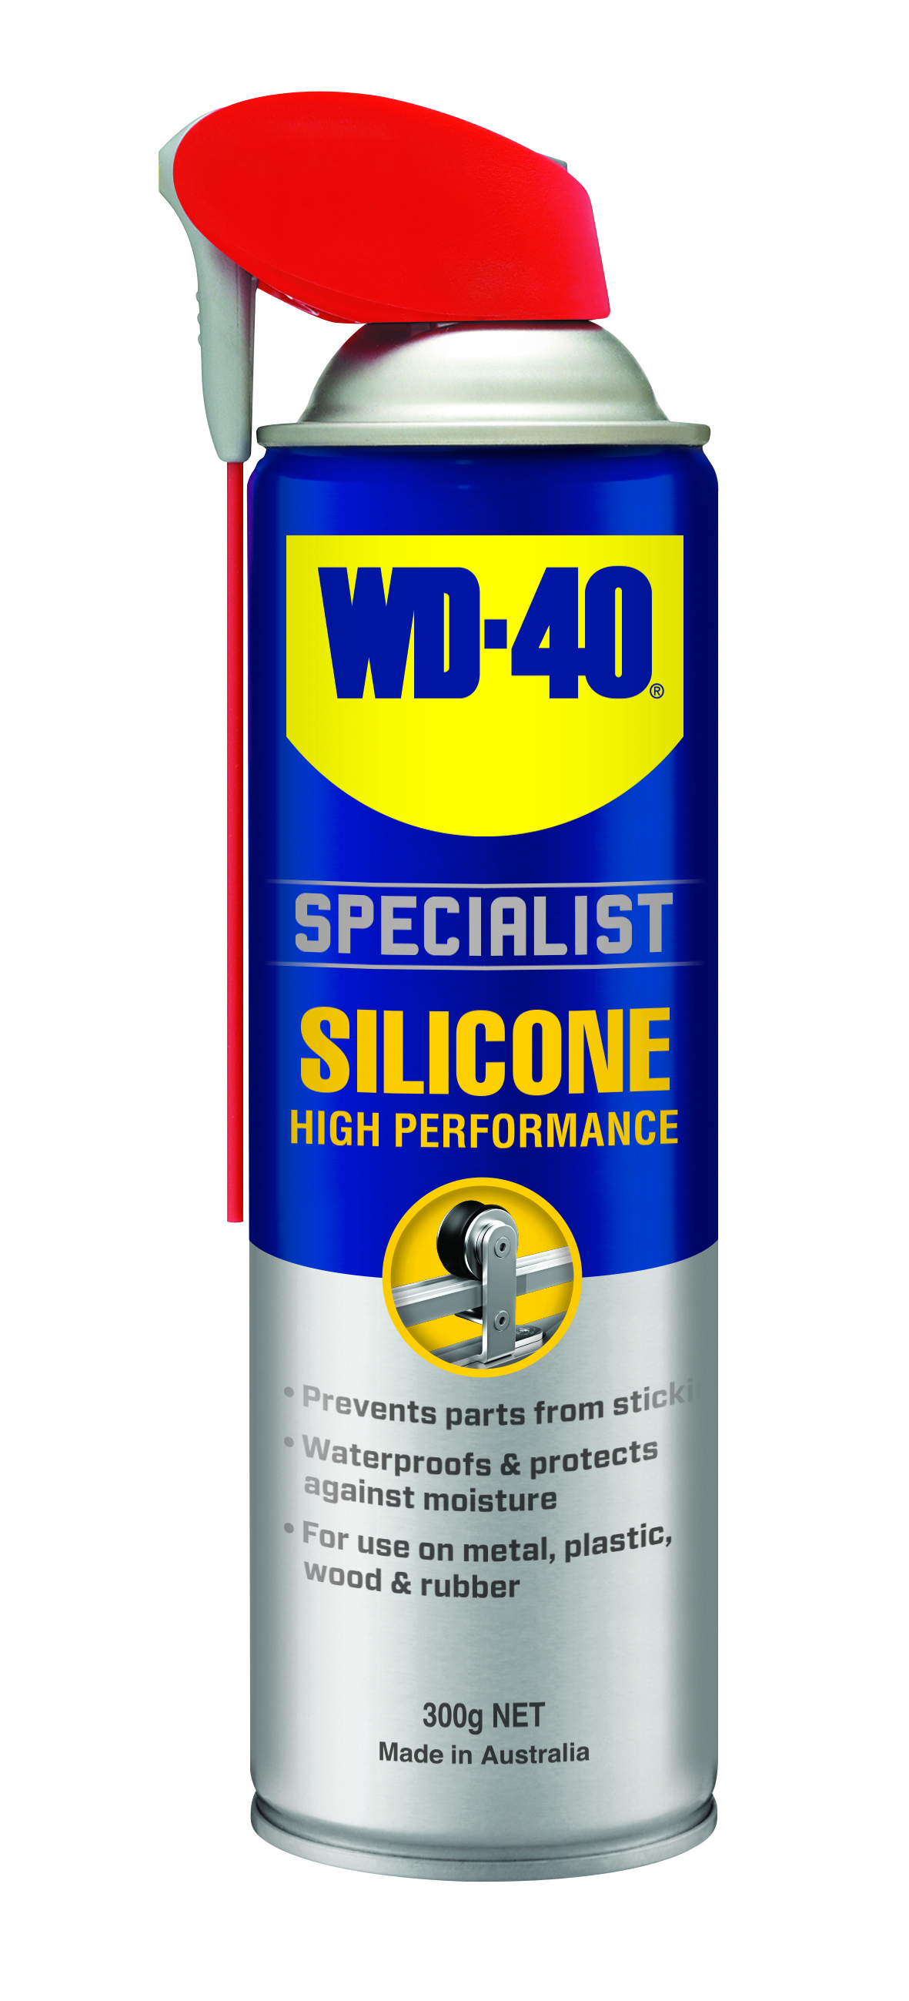
Applications | Features & Benefits
- Pipes  - Tools  - Guide Rails  - Valves  - Linkages  - Hinges  - Door | - Lubricates, waterproofs and protects  - Safe to use on rubber, vinyl and plastic  - Effective in temperature ranges from -40°C to +200°C
fluid Properties

Packaging Specifications

SKU Codes and Description |  |  | Individual Item (Consumer Unit) |  |  |  |  | Carton (Traded Unit) |  |  |  |  |  | Pallet Information
Case Codes | Unit Codes | Product Description | Dimensions (mm) |  |  | Cubic Volume (cm³) | Gross Weight (kg) | Dimensions (mm) |  |  | Cubic Volume (cm³) | Gross Weight (kg) | Units  Per  Carton | Consumer Units Per Pallet | Dimensions (mm) |  |  | Gross Weight (kg)
Case Codes | Unit Codes | Product Description | Width | Depth | Height | Cubic Volume (cm³) | Gross Weight (kg) | Width | Depth | Height |  |  |  |  | Width | Depth | Height | Gross Weight (kg)
21122 | 21025 | WD-40 Specialist High Performance Silicone Lubricant 300g Smart Straw | 132 | 66 | 245 | 2134 | 0.89 | 270 | 400 | 252 | 27216 | 11.15 | 12 | 480 | 1165 | 1165 | 1158 | 480

Directions
Shake can well before EACH spray. Flip straw up for narrow spray or down for wide spray. Spray directly on surface to be lubricated.


WD-40 Specialist®
Silicone

harzard identification
HAZARDOUS SUBSTANCE. DANGEROUS GOODS. According to the WHS Regulations and the ADG Code.
DANGER! Extremely flammable aerosol. Pressurized container: may burst if heated. May be fatal if swallowed and enters airways. May cause an allergic skin reaction. Harmful to aquatic life with long lasting effects. Repeated exposure may cause skin dryness or cracking. Keep away from heat, hot surfaces, sparks, open flames and other ignition sources. No smoking. Do not spray on an open flame or other ignition source. Do not pierce or burn, even after use. Avoid breathing mist or vapors. Contaminated work clothing should not be allowed out of the workplace. Avoid release to the environment. Wear protective gloves. If swallowed: Immediately call a POISON CENTER or doctor. DO NOT induce vomiting. IF ON SKIN: Wash with plenty of soap and water. Take off contaminated clothing and wash it before reuse. If discomfort persists, see a doctor. Additional information is listed in the safety data sheet.

Storage
Store in a cool, dry, ventilated area away from incompatible materials. Protect from physical damage. Do not store in direct sunlight, near open flames or above temperatures greater than 50°C.

Regulatory Information
Montreal Protocol (Ozone Depleting Substances): None present. The Stockholm Convention (Persistent Organic Pollutants): None present. The Rotterdam Convention (Prior Informed Consent): Not applicable. Basel Convention: Not applicable. International Convention for the Prevention of Pollution from Ships (MARPOL): D-Limonene (as Dipentene) is listed. Standard for the Uniform Scheduling of Medicines and Poisons (SUSMP): Not applicable

Australian Inventory of Chemical Substances: All the components of this product are listed on the AICS inventory
New Zealand Inventory: All the ingredients comply with the HSNO regulations

Level 2, 41 Rawson Street, Epping, NSW 2121 Australia Version: 1.0
wd40.com.au

TECHNICAL DATA SHEET

