BOILING POINT (INITIAL): | 190-208°C | SPECIFIC GRAVITY: | 0.77 typical at 21°C
SOLUBILITY IN WATER: | Insoluble | pH: | Not applicable
VAPOR PRESSURE: | Not determined | VAPOR DENSITY: | Not determined
PERCENT VOLATILE: | Not determined | VOC: | Not determined
COEFFICIENT OF WATER/OIL DISTRIBUTION: | Not Determined | APPEARANCE/ODOR: | Colorless liquid with a pleasant odor
FLASHPOINT: | 62°C | FLAMMABLE LIMITS: | LEL 0.7% UEL 6.0%
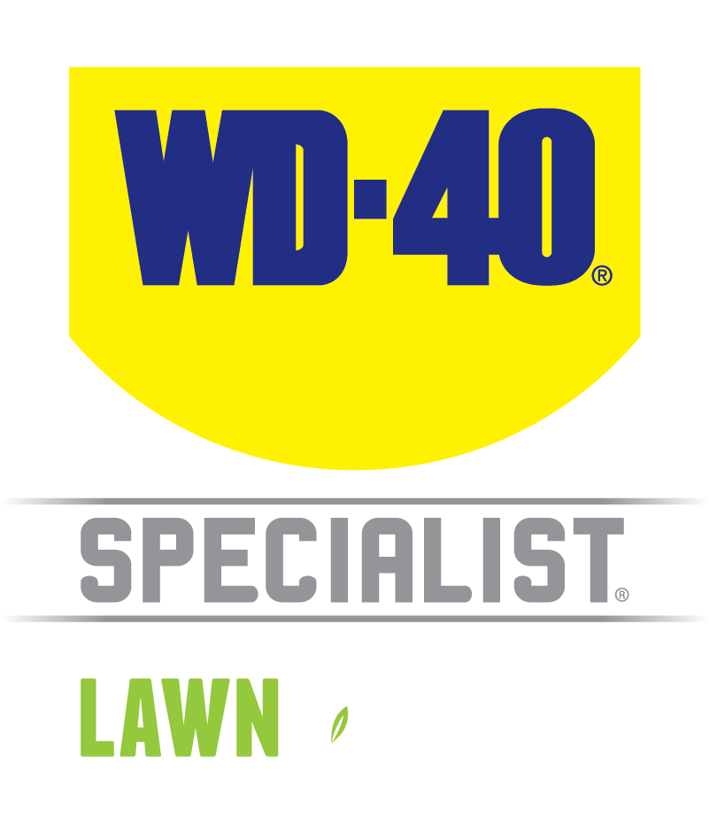

TECHNICAL DATA SHEET

WD-40 Specialist®
L&G Silicone

Product Description |  | PACKAGING
WD-40 Specialist Lawn & Garden Silicone is formulated to waterproof in wet, muddy, humid weather condition. It protects your tools with a clear, dry film, waterproofs against weather, lubricates and prevents residue sticking and helps parts run smoother. Recommended for use on garden mulchers, hedge trimmers, garden shears and lawn mowers, it will help to keep them run smoothly. |  | 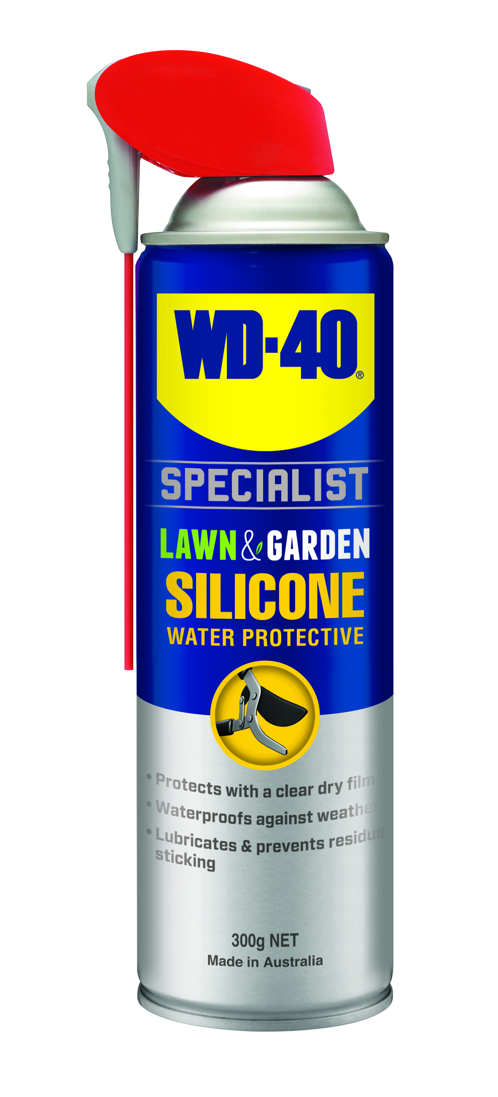
Applications | Features & Benefits
- Garden shears  - Lawn mowers and blades  - Hedge trimmers  - Secateurs and branch loppers  - Lawn edger  - Shovels | - Protects with a clear dry film  - Lubricates to help parts run smoothly  - Waterproofs against weather  - Safe for plastic, metal and wood surfaces
Fuild Properties

Packaging Specifications

SKU Codes and Description |  |  | Individual Item (Consumer Unit) |  |  |  |  | Carton (Traded Unit) |  |  |  |  |  | Pallet Information
Case Codes | Unit Codes | Product Description | Dimensions (mm) |  |  | Cubic Volume (cm³) | Gross Weight (kg) | Dimensions (mm) |  |  | Cubic Volume (cm³) | Gross Weight (kg) | Units  Per  Carton | Consumer Units Per Pallet | Dimensions (mm) |  |  | Gross Weight (kg)
Case Codes | Unit Codes | Product Description | Width | Depth | Height | Cubic Volume (cm³) | Gross Weight (kg) | Width | Depth | Height |  |  |  |  | Width | Depth | Height | Gross Weight (kg)
91103 | 91003 | WD-40 Specialist Lawn & Garden Water Protective Silicone 300g Smart Straw | 66 | 66 | 245 | 1067 | 0.44 | 137 | 204 | 253 | 7071 | 2.75 | 6 | 1008 | 1165 | 1165 | 1162 | 496

Directions
Shake can well before each use. Flip straw up for NARROW SPRAY or down for WIDE SPRAY. Ensure surface is clean and dry before application. Spray surface to be treated liberally. Use Smart Straw or hard to reach area. When using for lubricating moving parts, work parts back and forth after application. When using on coating or rubbers, test on a small inconspicuous area first. ensure power/ moor is turned off and cool prior to uses. Please refer to your owner's manual before use.


TECHNICAL DATA SHEET

WD-40 Specialist®
L&G Silicone

harzard identification
HAZARDOUS SUBSTANCE. DANGEROUS GOODS. According to the WHS Regulations and the ADG Code.
DANGER! Extremely flammable aerosol. Pressurized container: may burst if heated. May be fatal if swallowed and enters airways. May cause an allergic skin reaction. Harmful to aquatic life with long lasting effects. Repeated exposure may cause skin dryness or cracking. Keep away from heat, hot surfaces, sparks, open flames and other ignition sources. No smoking. Do not spray on an open flame or other ignition source. Do not pierce or burn, even after use. Avoid breathing mist or vapors. Contaminated work clothing should not be allowed out of the workplace. Avoid release to the environment. Wear protective gloves. If swallowed: Immediately call a POISON CENTER or doctor. DO NOT induce vomiting. IF ON SKIN: Wash with plenty of soap and water. Take off contaminated clothing and wash it before reuse. If discomfort persists, see a doctor. Additional information is listed in the safety data sheet.

Storage
Store in a cool, dry, ventilated area away from incompatible materials. Protect from physical damage. Do not store in direct sunlight, near open flames or above temperatures greater than 50°C.
Regulatory Information
Montreal Protocol (Ozone Depleting Substances): None present. The Stockholm Convention (Persistent Organic Pollutants): None present. The Rotterdam Convention (Prior Informed Consent): Not applicable. Basel Convention: Not applicable. International Convention for the Prevention of Pollution from Ships (MARPOL): D-Limonene (as Dipentene) is listed. Standard for the Uniform Scheduling of Medicines and Poisons (SUSMP): Not applicable

Australian Inventory of Chemical Substances: All the components of this product are listed on the AICS inventory
New Zealand Inventory: All the ingredients comply with the HSNO regulations

Level 2, 41 Rawson Street, Epping, NSW 2121 Australia Version: 1.0
wd40.com.au

