BOILING POINT (INITIAL): | >218°C | SPECIFIC GRAVITY: | 0.82 typical at 25°C
SOLUBILITY IN WATER: | Insoluble | pH: | Not applicable
VAPOR PRESSURE: | Not determined | VAPOR DENSITY: | Not determined
PERCENT VOLATILE: | Not determined | VOC: | Not determined
COEFFICIENT OF WATER/OIL DISTRIBUTION: | Not determined | APPEARANCE/ODOR: | Off white liquid with a faint citronella odor
FLASHPOINT: | >93.5°C | FLAMMABLE LIMITS: | LEL 0.6% UEL 5.0%
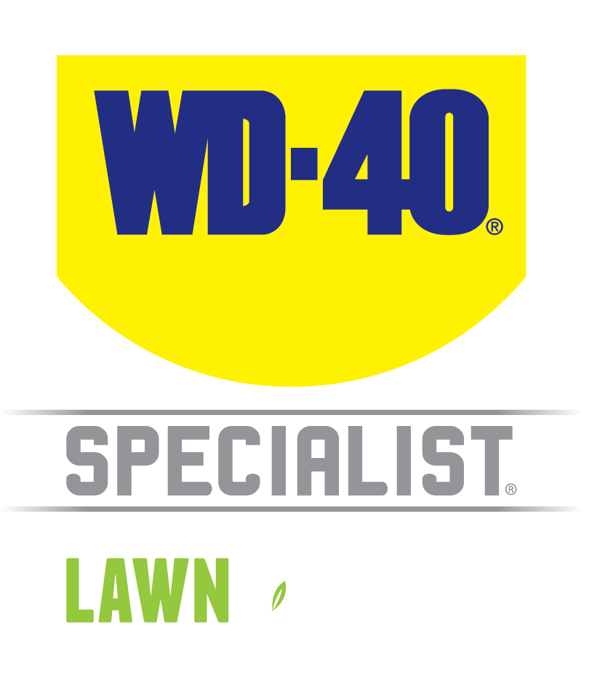

TECHNICAL DATA SHEET

WD-40 Specialist®
L&G Grease

Product Description |  | PACKAGING
WD-40 Specialist Lawn & Garden Tool Protectant Grease is formulated for metal-to-metal lubrication in all weather conditions. This grease has long lasting wear protection, prevents rust and corrosion and bright white pigment for viewing and re-application. Ideal for pre-storage rust protection and keeps bearings, blades and metal parts working smoothly on soil cultivators, lawn edgers, tillers and wheelbarrow bearings. Also great for protecting exposed screws, bolts, hinges on gates and sheds. |  | 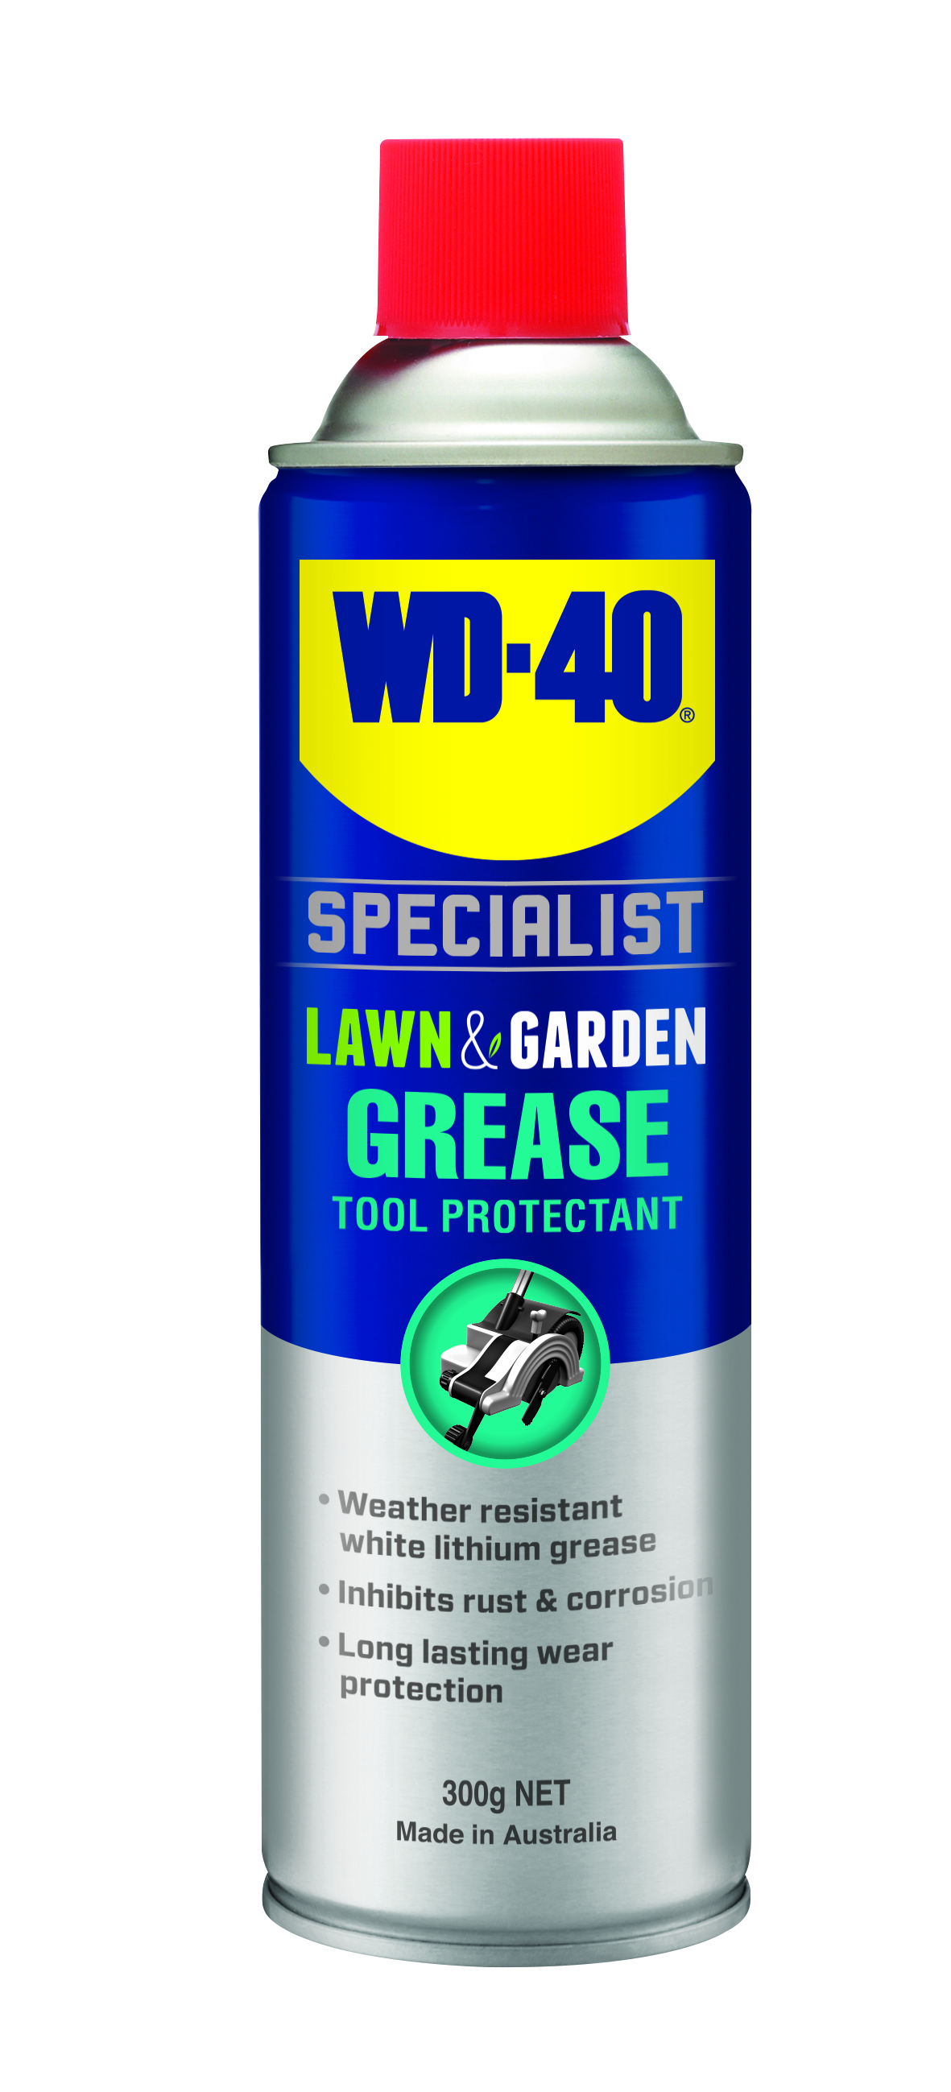
Applications | Features & Benefits
- Soil cultivators  - Wheelbarrow bearings  - Trailer tow bars  - Lawnmowers  - Metal gates and garage doors  - Whipper snippers | - Weather resistant white lithium grease  - Prevents rust and corrosion  - Long lasting wear protection and ideal for items in storage  - Reduces friction on metal-to-metal parts  - Bright white pigment for easy viewing and re-application
fluid Properties

Packaging Specifications
SKU Codes and Description |  |  | Individual Item (Consumer Unit) |  |  |  |  | Carton (Traded Unit) |  |  |  |  |  | Pallet Information
Case Codes | Unit Codes | Product Description | Dimensions (mm) |  |  | Cubic Volume (cm³) | Gross Weight (kg) | Dimensions (mm) |  |  | Cubic Volume (cm³) | Gross Weight (kg) | Units  Per  Carton | Consumer Units Per Pallet | Dimensions (mm) |  |  | Gross Weight (kg)
Case Codes | Unit Codes | Product Description | Width | Depth | Height | Cubic Volume (cm³) | Gross Weight (kg) | Width | Depth | Height |  |  |  |  | Width | Depth | Height | Gross Weight (kg)
91104 | 91004 | WD-40 Specialist Lawn & Garden Tool Protectant Grease 300g | 66 | 66 | 239 | 1041 | 0.43 | 137 | 204 | 253 | 7071 | 2.69 | 6 | 1200 | 1165 | 1165 | 1415 | 572

Directions
Shake can well. Ensure surface is clean and dry before application. Spray surface to be treated liberally ensuring full coverage for maximum protection. when used for lubricating moving parts work parts back and forth after application. wash off any excess liquid. Repeat as necessary. When using on coatings or rubbers, test on a small Inconspicuous area first. Ensure power/motor Is turned off ad cool prior to use. please refer to your owner's manual before use.


;
TECHNICAL DATA SHEET

WD-40 Specialist®
L&G GREASE

hazard identification
HAZARDOUS SUBSTANCE. DANGEROUS GOODS. According to the WHS Regulations and the ADG Code.
DANGER! Extremely flammable aerosol. Pressurized container: may burst if heated. May be fatal if swallowed and enters airways. May cause an allergic skin reaction. Harmful to aquatic life with long lasting effects. Repeated exposure may cause skin dryness or cracking. Keep away from heat, hot surfaces, sparks, open flames and other ignition sources. No smoking. Do not spray on an open flame or other ignition source. Do not pierce or burn, even after use. Avoid breathing mist or vapors. Contaminated work clothing should not be allowed out of the workplace. Avoid release to the environment. Wear protective gloves. If swallowed: Immediately call a POISON CENTER or doctor. DO NOT induce vomiting. If on skin: Wash with plenty of soap and water. If skin Irritation or rash occurs: Get medical attention. Take off contaminated clothing and wash it before reuse. If discomfort persists, see a doctor. Additional information is listed in the safety data sheet.
Storage
Store in a cool, dry, ventilated area away from incompatible materials. Protect from physical damage. Do not store in direct sunlight, near open flames or above temperatures greater than 50°C.
Regulatory Information
Montreal Protocol (Ozone Depleting Substances): None present. The Stockholm Convention (Persistent Organic Pollutants): None present. The Rotterdam Convention (Prior Informed Consent): Not applicable. Basel Convention: Not applicable. International Convention for the Prevention of Pollution from Ships (MARPOL): Not applicable. Standard for the Uniform Scheduling of Medicines and Poisons (SUSMP): Not applicable

Australian Inventory of Chemical Substances: All the components of this product are listed on the AICS inventory
New Zealand Inventory: All the ingredients comply with the HSNO regulations

Level 2, 41 Rawson Street, Epping, NSW 2121 Australia Version: 1.0
wd40.com.au

