

WD-40 Specialist®
L&G GENERAL USE LUBRICANT

TECHNICAL DATA SHEET

Product Description |  | PACKAGING
WD-40 Specialist Lawn & Garden General Use Lubricant provides excellent lubrication, reduces friction, and protects your tools. It helps to reduce friction and wear in outdoor conditions, and also provides excellent lubrication for exposed joints, great for cleaning metal surfaces, protect garden equipment and prevents rust and corrosion. |  | 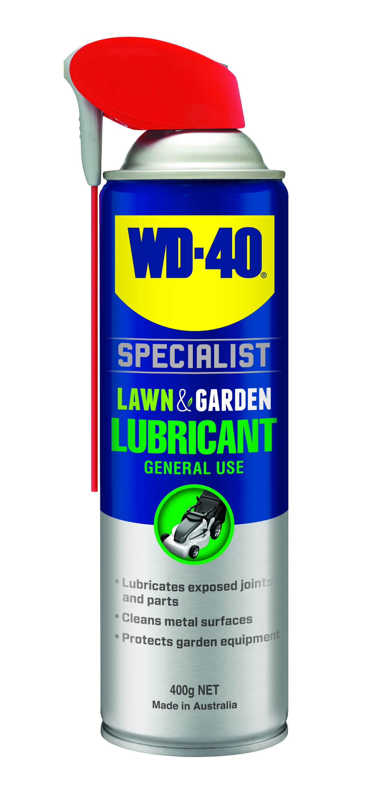
Applications | Features & Benefits
- Secateurs  - Lawn edgers  - Chainsaws  - Manual and power mowers  - Branch loppers  - Outdoor taps and sprinklers | - Lubricates exposed joints and parts  - Cleans metal surfaces  - Protects garden equipment
Fluid Properties
BOILING POINT (INITIAL): | 200-250°C | SPECIFIC GRAVITY: | 0.82 typical at 21°C
SOLUBILITY IN WATER: | Insoluble | pH: | Not Applicable
VAPOR PRESSURE: | Not determined | VAPOR DENSITY: | Not determined
PERCENT VOLATILE: | Not determined | VOC: | >35%
COEFFICIENT OF WATER/OIL DISTRIBUTION: | Not determined | APPEARANCE/ODOR: | Light amber liquid with a mild petroleum odor.
FLASHPOINT: | 75°C | FLAMMABLE LIMITS: | LEL: 0.6% UEL: 7%

Packaging Specifications
SKU Codes and Description |  |  | Individual Item (Consumer Unit) |  |  |  |  | Carton (Traded Unit) |  |  |  |  |  | Pallet Information
Case Codes | Unit Codes | Product Description | Dimensions (mm) |  |  | Cubic Volume (cm³) | Gross Weight (kg) | Dimensions (mm) |  |  | Cubic Volume (cm³) | Gross Weight (kg) | Units  Per  Carton | Consumer Units Per Pallet | Dimensions (mm) |  |  | Gross Weight (kg)
Case Codes | Unit Codes | Product Description | Width | Depth | Height | Cubic Volume (cm³) | Gross Weight (kg) | Width | Depth | Height |  |  |  |  | Width | Depth | Height | Gross Weight (kg)
91101 | 91001 | WD-40 Specialist Lawn & Garden Powerful Foaming Cleaner 400g | 66 | 66 | 239 | 1041 | 0.525 | 137 | 204 | 253 | 7071 | 3.26 | 6 | 1200 | 1165 | 1165 | 1415 | 686

Directions
Shake can well before each use. Flip straw up for narrow spray or down for wide spray. Ensure surface Is clean and dry before application. Saturate area to be treated and let soak for several minutes. for best rust protection, do not wipe off and ensure full coverage. when using for lubricating moving part, work parts back and forth after application. when using on coating or rubbers, test on a small Inconspicuous area first. Ensure power/motor Is turned off and cool prior to use. Do not spray horizontally.


WD-40 Specialist®
L&G GENERAL USE LUBRICANT

TECHNICAL DATA SHEET

Hazard identification
HAZARDOUS SUBSTANCE. DANGEROUS GOODS. According to the WHS Regulations and the ADG Code.
DANGER! Extremely flammable aerosol. Pressurized container: may burst if heated. May be fatal if swallowed and enters airways. May cause an allergic skin reaction. Harmful to aquatic life with long lasting effects. Repeated exposure may cause skin dryness or cracking. Keep away from heat, hot surfaces, sparks, open flames and other ignition sources. No smoking. Do not spray on an open flame or other ignition source. Do not pierce or burn, even after use. Avoid breathing mist or vapors. Contaminated work clothing should not be allowed out of the workplace. Avoid release to the environment. Wear protective gloves. If on skin: Wash with plenty of soap and water. If skin Irritation or rash occurs: Get medical attention. Take off contaminated clothing and wash it before reuse. If swallowed: Immediately call a POISON CENTER or doctor. DO NOT induce vomiting. If discomfort persists, see a doctor. Additional information is listed in the safety data sheet.
Storage
Store in a cool, dry, ventilated area away from incompatible materials. Protect from physical damage. Do not store in direct sunlight, near open flames or above temperatures greater than 50°C.
Regulatory Information
Montreal Protocol (Ozone Depleting Substances): None present. The Stockholm Convention (Persistent Organic Pollutants): None present. The Rotterdam Convention (Prior Informed Consent): Not applicable. Basel Convention: Not applicable. International Convention for the Prevention of Pollution from Ships (MARPOL): D-Limonene (as Dipentene) is listed. Standard for the Uniform Scheduling of Medicines and Poisons (SUSMP): Not applicable

Australian Inventory of Chemical Substances: All the components of this product are listed on the AICS inventory
New Zealand Inventory: All the ingredients comply with the HSNO regulations.
Level 2, 41 Rawson Street, Epping, NSW 2121 Australia Version: 1.0
wd40.com.au

