BOILING POINT (INITIAL): | 100°C | SPECIFIC GRAVITY: | 0.99 typical at 21°C
SOLUBILITY IN WATER: | Miscible | pH: | 11
VAPOR PRESSURE: | Not determined | VAPOR DENSITY: | >1
PERCENT VOLATILE: | Not determined | VOC: | 21%
COEFFICIENT OF WATER/OIL DISTRIBUTION: | Not determined | APPEARANCE/ODOR: | Light amber liquid with citrus odor
FLASHPOINT: | Not determined | FLAMMABLE LIMITS: | LEL 1.8% UEL 9.5%


TECHNICAL DATA SHEET

WD-40 Specialist®
lawn & garden cleaner

Product Description |  | PACKAGING
WD-40 Specialist Lawn & Garden Cleaner cleans resin, sap, dirt and deposits from garden tools and equipment. The water-based citrus formula has a powerful foaming action to remove oil, grease and residue. it is fast acting and easy to rinse. |  | 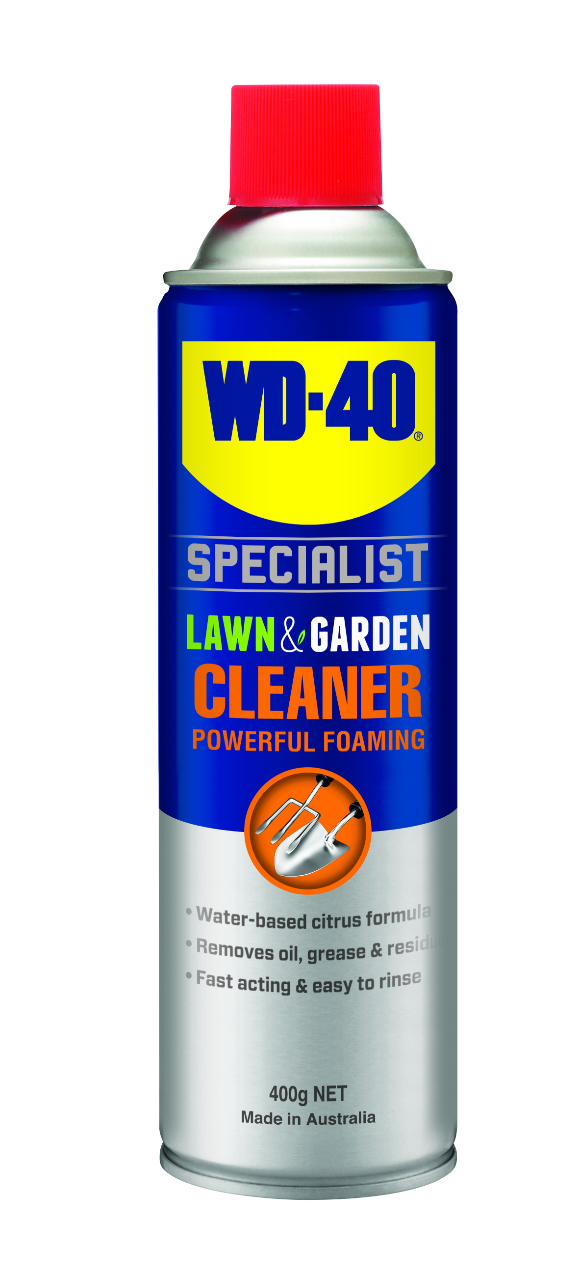
Applications | Features & Benefits
- Secateurs & Branch Lopper  - Gardening Tools  - Lawn Mowers  - Whipper Snippers  - Pruner | - Removes grease, oil, fat, dirt & grime  - Powerful foam works immediately on contact  - Easy to rinse with water  - Powerful formula designed to lift engine grease and carbon deposits
FUILD Properties

Packaging Specifications
SKU Codes and Description |  |  | Individual Item (Consumer Unit) |  |  |  |  | Carton (Traded Unit) |  |  |  |  |  | Pallet Information
Case Codes | Unit Codes | Product Description | Dimensions (mm) |  |  | Cubic Volume (cm³) | Gross Weight (kg) | Dimensions (mm) |  |  | Cubic Volume (cm³) | Gross Weight (kg) | Units  Per  Carton | Consumer Units Per Pallet | Dimensions (mm) |  |  | Gross Weight (kg)
Case Codes | Unit Codes | Product Description | Width | Depth | Height | Cubic Volume (cm³) | Gross Weight (kg) | Width | Depth | Height |  |  |  |  | Width | Depth | Height | Gross Weight (kg)
91101 | 91001 | WD-40 Specialist Lawn & Garden Powerful Foaming Cleaner 400g | 66 | 66 | 239 | 1041 | 0.525 | 137 | 204 | 253 | 7071 | 3.26 | 6 | 1200 | 1165 | 1165 | 1415 | 686

Directions
Ensure power/motor is turned off and cool prior to use. Please refer to your owner's manual before use. Shake can well. Spray surface to be treated liberally. Allow to penetrate before agitation with a brush or cloth. foaming action helps break down and clean treated area. Wash off any excess liquid. Repeat as necessary. When cleaning coatings or rubbers, test on a small Inconspicuous area first. Avoid prolonged contact with rubbers and DO NOT use on painted or powder-coated surfaces.

hazard indentification
HAZARDOUS SUBSTANCE. DANGEROUS GOODS. According to the WHS Regulations and the ADG Code.
DANGER! Extremely flammable aerosol. Pressurized container: may burst if heated. Causes skin irritation. May cause an allergic skin reaction. Causes serious eye irritation. Toxic to aquatic life with long lasting effects. Keep away from heat, hot surfaces, sparks, open flames and other ignition sources. No smoking. Do not spray on an open flame or other ignition source. Do not pierce or burn, even after use. Avoid breathing mist or vapors. Wash thoroughly after handling. Contaminated work clothing should not be allowed out of the workplace. Avoid release to the environment. Wear protective gloves and eye protection. If in eyes: Rinse cautiously with water for several minutes. Remove contact lenses, if present and easy to do. Continue rinsing. If on skin: wash with plenty of soap and water. Take off contaminated clothing and wash before reuse. If discomfort persists, see a doctor. Additional information is listed in the safety data sheet.
Storage
Store in a cool, dry, ventilated area away from incompatible materials. Protect from physical damage. Do not store in direct sunlight, near open flames or above temperatures greater than 50°C.
Regulatory Information
Montreal Protocol (Ozone Depleting Substances): None present. The Stockholm Convention (Persistent Organic Pollutants): None present. The Rotterdam Convention (Prior Informed Consent): Not applicable. Basel Convention: Not applicable. International Convention for the Prevention of Pollution from Ships (MARPOL): D-Limonene (as Depentene) is listed. Standard for the Uniform Scheduling of Medicines and Poisons (SUSMP): Not applicable

Australian Inventory of Chemical Substances: All the components of this product are listed on the AICS inventory
New Zealand Inventory: All the ingredients comply with the HSNO regulations


TECHNICAL DATA SHEET

Level 2, 41 Rawson Street, Epping, NSW 2121 Australia Version: 1.0
wd40.com.au

WD-40 Specialist®
Degreaser

