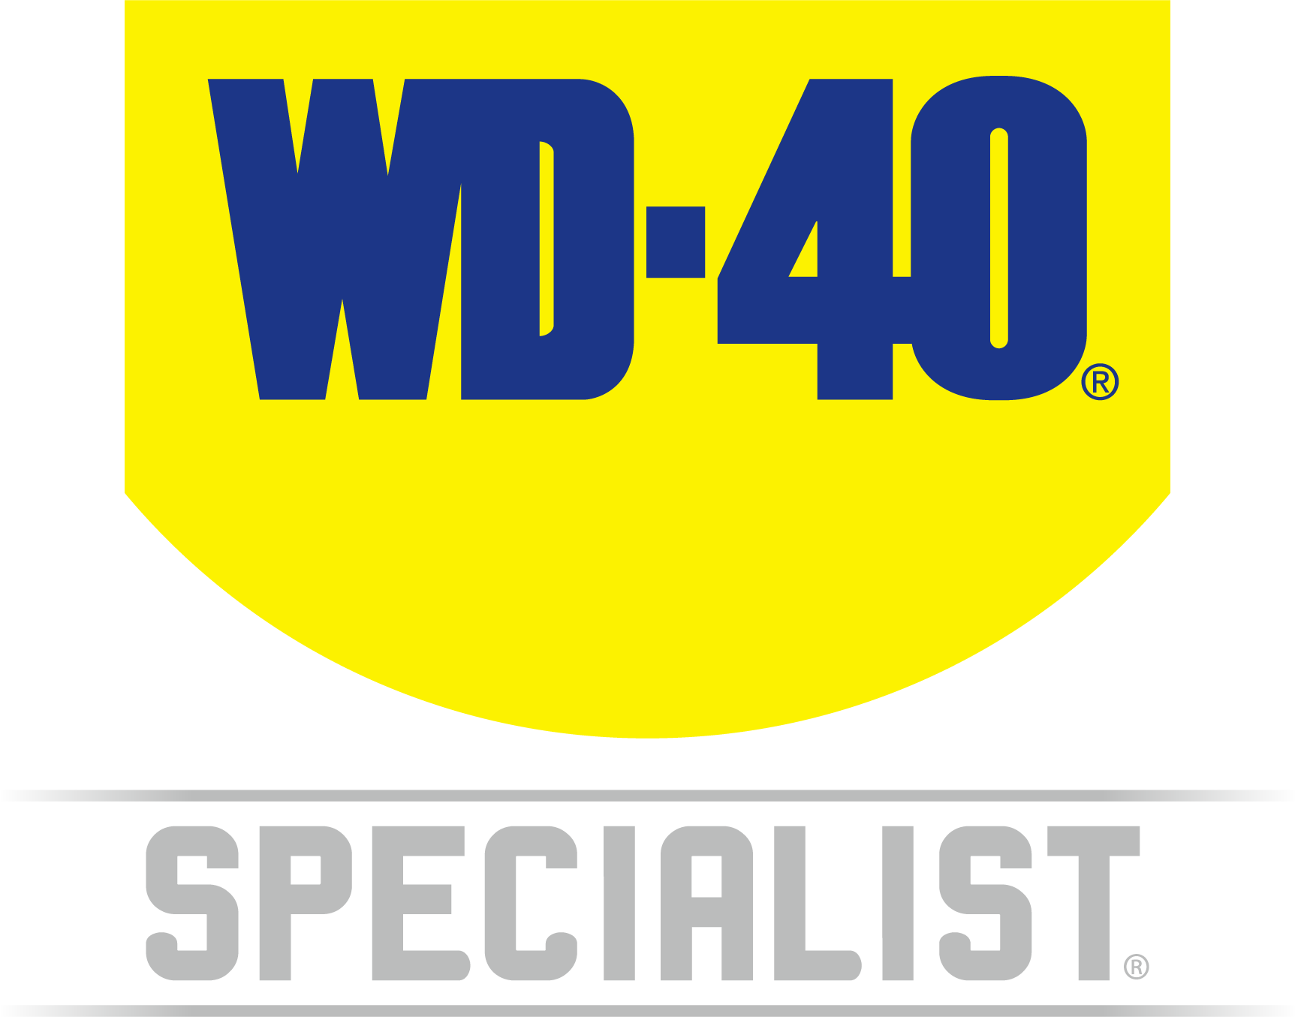

TECHNICAL DATA SHEET

WD-40 Specialist®
WHITE LITHIUM GREASE

Product Description |  | PACKAGING
WD-40 Specialist White Lithium Grease is an aerosol grease that sprays on evenly and leaves behind a rust-inhibiting barrier for protection against corrosion that won't run off. This long-lasting formula won't melt, freeze, or run in harsh weather conditions. It is safe to use on metals and ideal for metal-to-metal applications, reducing friction to ensure your tools and equipment keep moving smoothly. Also great for lubricating equipment before placing in storage. For use on outdoor and automotive hinges, gears, sprockets, latches, door tracks, pulleys, cables and guide rails. Effective in extreme temperatures ranging from -30°C to 150°C. |  | 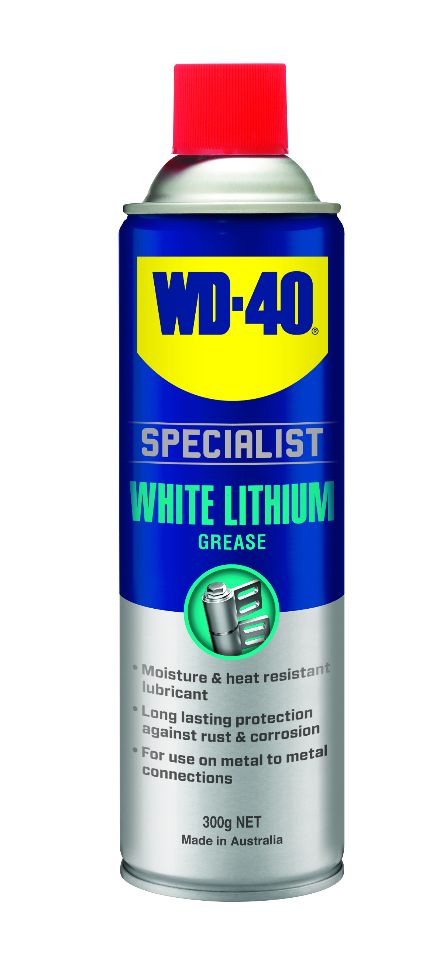
Applications | Features & Benefits
- Auto Hinges  - Gears  - Sprockets  - Outdoor Hinges  - Latches  - Overhead Door Tracks  - Pulleys  - Cables | - Long-lasting lubrication and protection  - Won't freeze melt or run off  - Ideal for metal-to-metal applications  - Effective in a temperature Ranges from -30°C to 150°C
Fluid Properties
BOILING POINT (INITIAL): | >218°C | SPECIFIC GRAVITY: | 0.82 typical at 25°C
SOLUBILITY IN WATER: | Insoluble | pH: | Not applicable
VAPOR PRESSURE: | Not determined | VAPOR DENSITY: | Not determined
PERCENT VOLATILE: | Not determined | VOC: | Not determined
COEFFICIENT OF WATER/OIL DISTRIBUTION: | Not determined | APPEARANCE/ODOR: | Off white liquid with a faint citronella odor
FLASHPOINT: | >93.5°C | FLAMMABLE LIMITS: | LEL 0.6% UEL 5.0%

Packaging Specifications
SKU Codes and Description |  |  | Individual Item (Consumer Unit) |  |  |  |  | Carton (Traded Unit) |  |  |  |  |  | Pallet Information
Case Codes | Unit Codes | Product Description | Dimensions (mm) |  |  | Cubic Volume (cm³) | Gross Weight (kg) | Dimensions (mm) |  |  | Cubic Volume (cm³) | Gross Weight (kg) | Units  Per  Carton | Consumer Units Per Pallet | Dimensions (mm) |  |  | Gross Weight (kg)
Case Codes | Unit Codes | Product Description | Width | Depth | Height | Cubic Volume (cm³) | Gross Weight (kg) | Width | Depth | Height |  |  |  |  | Width | Depth | Height | Gross Weight (kg)
21102 | 21002 | WD-40 Specialist High Performance White Lithium Grease 300g | 66 | 66 | 240 | 1045.4 | 0.43 | 137 | 200 | 245 | 6713 | 2.69 | 6 | 1200 | 1165 | 1165 | 1375 | 572

Directions
Shake can well. Apply by spraying directly on surface to be lubricated ensuring full coverage for maximum protection.


TECHNICAL DATA SHEET

WD-40 Specialist®
WHITE LITHIUM GREASE

harzard identification
HAZARDOUS SUBSTANCE. DANGEROUS GOODS. According to the WHS Regulations and the ADG Code.
DANGER! Extremely flammable aerosol. Pressurized container: may burst if heated. May be fatal if swallowed and enters airways. May cause an allergic skin reaction. Harmful to aquatic life with long lasting effects. Repeated exposure may cause skin dryness or cracking. Keep away from heat, hot surfaces, sparks, open flames and other ignition sources. No smoking. Do not spray on an open flame or other ignition source. Do not pierce or burn, even after use. Avoid breathing mist or vapors. Contaminated work clothing should not be allowed out of the workplace. Avoid release to the environment. Wear protective gloves. If swallowed: Immediately call a POISON CENTER or doctor. DO NOT induce vomiting. If on skin: Wash with plenty of soap and water. If skin Irritation or rash occurs: Get medical attention.
Take off contaminated clothing and wash it before reuse. If discomfort persists, see a doctor. Additional information is listed in the safety data sheet.
Storage
Store in a cool, dry, ventilated area away from incompatible materials. Protect from physical damage. Do not store in direct sunlight, near open flames or above temperatures greater than 50°C.
Regulatory Information
Montreal Protocol (Ozone Depleting Substances): None present. The Stockholm Convention (Persistent Organic Pollutants): None present. The Rotterdam Convention (Prior Informed Consent): Not applicable. Basel Convention: Not applicable. International Convention for the Prevention of Pollution from Ships (MARPOL): Not applicable. Standard for the Uniform Scheduling of Medicines and Poisons (SUSMP): Not applicable

Australian Inventory of Chemical Substances: All the components of this product are listed on the AICS inventory
New Zealand Inventory: All the ingredients comply with the HSNO regulations

Level 2, 41 Rawson Street, Epping, NSW 2121 Australia Version: 1.0
wd40.com.au

