BOILING POINT (INITIAL): | 130-166°C | SPECIFIC GRAVITY | 0.77 typical at 21°C
SOLUBILITY IN WATER: | Insoluble | pH: | Not Applicable
VAPOR PRESSURE: | Not determined | VAPOR DENSITY: | Not determined
PERCENT VOLATILE: | Not determined | VOC: | Not determined
COEFFICIENT OF WATER/OIL DISTRIBUTION: | Not Determined | APPEARANCE/ODOR: | Clear liquid with a  characteristic odor.
FLASHPOINT: | >30°C | FLAMMABLE LIMITS: | LEL 0.6% UEL 7.0%


TECHNICAL DATA SHEET

WD-40 Specialist®
Penetrant

Product Description |  | PACKAGING
WD-40 Specialist Penetrant Fast-Acting formula works on contact while penetrating deep into seized mechanisms and fixing to loosen and free parts. It penetrates into tight crevices, threads and seams to break bonds that hold stuck parts together. Leaves behind a protective layer that prevents further rust and corrosion from re-forming. For use on metals, most plastics* and most rubbers*.  *Always test on an inconspicuous area before use. |  | 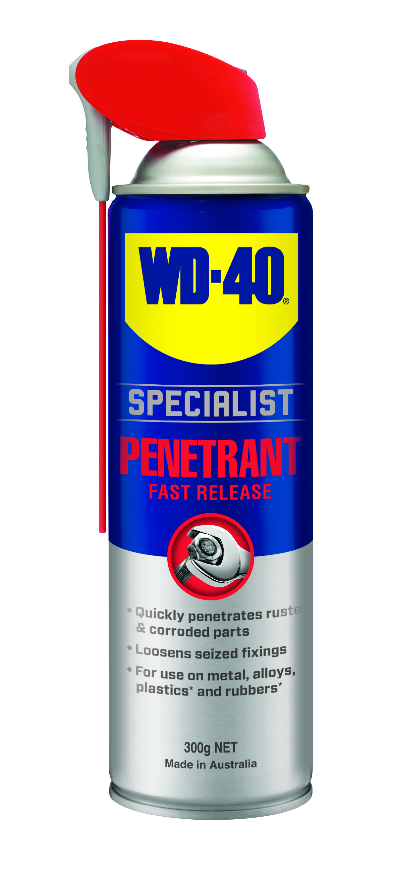
Applications | Features & Benefits
- Nuts & Bolts  - Bearing  - Screws  - Pipe Threads  - Locks  - Rusted Parts  - Stuck Components | - Quickly penetrates rusted & corroded parts  - Loosens seized fixings  - For use on multiple surface
fluid Properties

Packaging Specifications
SKU Codes and Description |  |  | Individual Item (Consumer Unit) |  |  |  |  | Carton (Traded Unit) |  |  |  |  |  | Pallet Information
Case Codes | Unit Codes | Product Description | Dimensions (mm) |  |  | Cubic Volume (cm³) | Gross Weight (kg) | Dimensions (mm) |  |  | Cubic Volume (cm³) | Gross Weight (kg) | Units  Per  Carton | Consumer Units Per Pallet | Dimensions (mm) |  |  | Gross Weight (kg)
Case Codes | Unit Codes | Product Description | Width | Depth | Height | Cubic Volume (cm³) | Gross Weight (kg) | Width | Depth | Height |  |  |  |  | Width | Depth | Height | Gross Weight (kg)
21112 | 21014 | WD-40 Specialist Fast Release Penetrant 300g Smart Straw | 66 | 66 | 245 | 1067 | 0.435 | 137 | 200 | 252 | 6910 | 2.72 | 6 | 1008 | 1165 | 1165 | 1158 | 490.96

Directions
Shake can well. Flip straw up for narrow spray or down for wider spray. Saturate the surface to be loosened, allow to soak for a few minutes. for highly seized fixings, repeat as necessary.


TECHNICAL DATA SHEET

WD-40 Specialist®
Penetrant

harzard identification
HAZARDOUS SUBSTANCE. DANGEROUS GOODS. According to the WHS Regulations and the ADG Code.
DANGER! Extremely flammable aerosol. Pressurized container: may burst if heated. May be fatal if swallowed and enters airways. May cause an allergic skin reaction. May cause drowsiness or dizziness. Harmful to aquatic life with long lasting effects. Repeated exposure may cause skin dryness or cracking. Keep away from heat, hot surfaces, sparks, open flames and other ignition sources. No smoking. Do not spray on an open flame or other ignition source. Do not pierce or burn, even after use. Avoid breathing mist or vapors. Use only outdoors or in a well-ventilated area. Contaminated work clothing should not be allowed out of the workplace. Avoid release to the environment. Wear protective gloves. IF ON SKIN: Wash with plenty of soap and water. Take off contaminated clothing and wash it before reuse. If inhaled: Remove person to fresh air and keep comfortable for breathing. If swallowed: Immediately call a POISON CENTER or doctor. DO NOT induce vomiting. If discomfort persists, see a doctor. Additional information is listed in the safety data sheet.

Storage
Store in a cool, dry, ventilated area away from incompatible materials. Protect from physical damage. Do not store in direct sunlight, near open flames or above temperatures greater than 50°C.
Regulatory Information
Montreal Protocol (Ozone Depleting Substances): None present. The Stockholm Convention (Persistent Organic Pollutants): None present. The Rotterdam Convention (Prior Informed Consent): Not applicable. Basel Convention: Not applicable. International Convention for the Prevention of Pollution from Ships (MARPOL): None present. Standard for the Uniform Scheduling of Medicines and Poisons (SUSMP): Not applicable

Australian Inventory of Chemical Substances: All the components of this product are listed on the AICS inventory
New Zealand Inventory: All the ingredients comply with the HSNO regulations

Level 2, 41 Rawson Street, Epping, NSW 2121 Australia Version: 1.0
wd40.com.au

