BOILING POINT (INITIAL): | >315.5°C | SPECIFIC GRAVITY: | 0.83 typical at 21°C
SOLUBILITY IN WATER: | Insoluble | pH: | Not applicable
VAPOR PRESSURE: | Not determined | VAPOR DENSITY: | Not determined
PERCENT VOLATILE: | Not determined | VOC: | Not determined
COEFFICIENT OF WATER/OIL DISTRIBUTION: | Not determined | APPEARANCE/ODOR: | Light amber liquid with a mild characteristic odor
FLASHPOINT: | >62°C | FLAMMABLE LIMITS: | LEL 0.7% UEL 7.0%
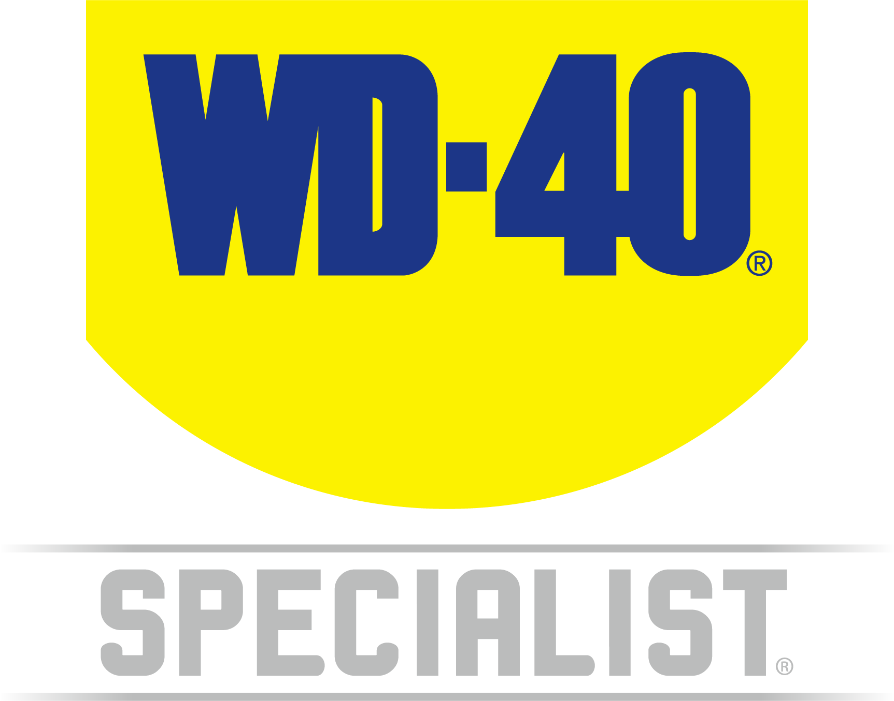

TECHNICAL DATA SHEET

WD-40 Specialist®
Lanolin

Product Description |  | PACKAGING
WD-40 Specialist Lanolin is a highly effective formulation for long term corrosion protection on metal surfaces under extreme climatic and high humidity conditions. This product generates a thick lanolin film which does not dry out or wash off easily with water. Highly resistant to salt, water, acid and humidity. Lanolin is a natural substance derived from sheep's wool. |  | 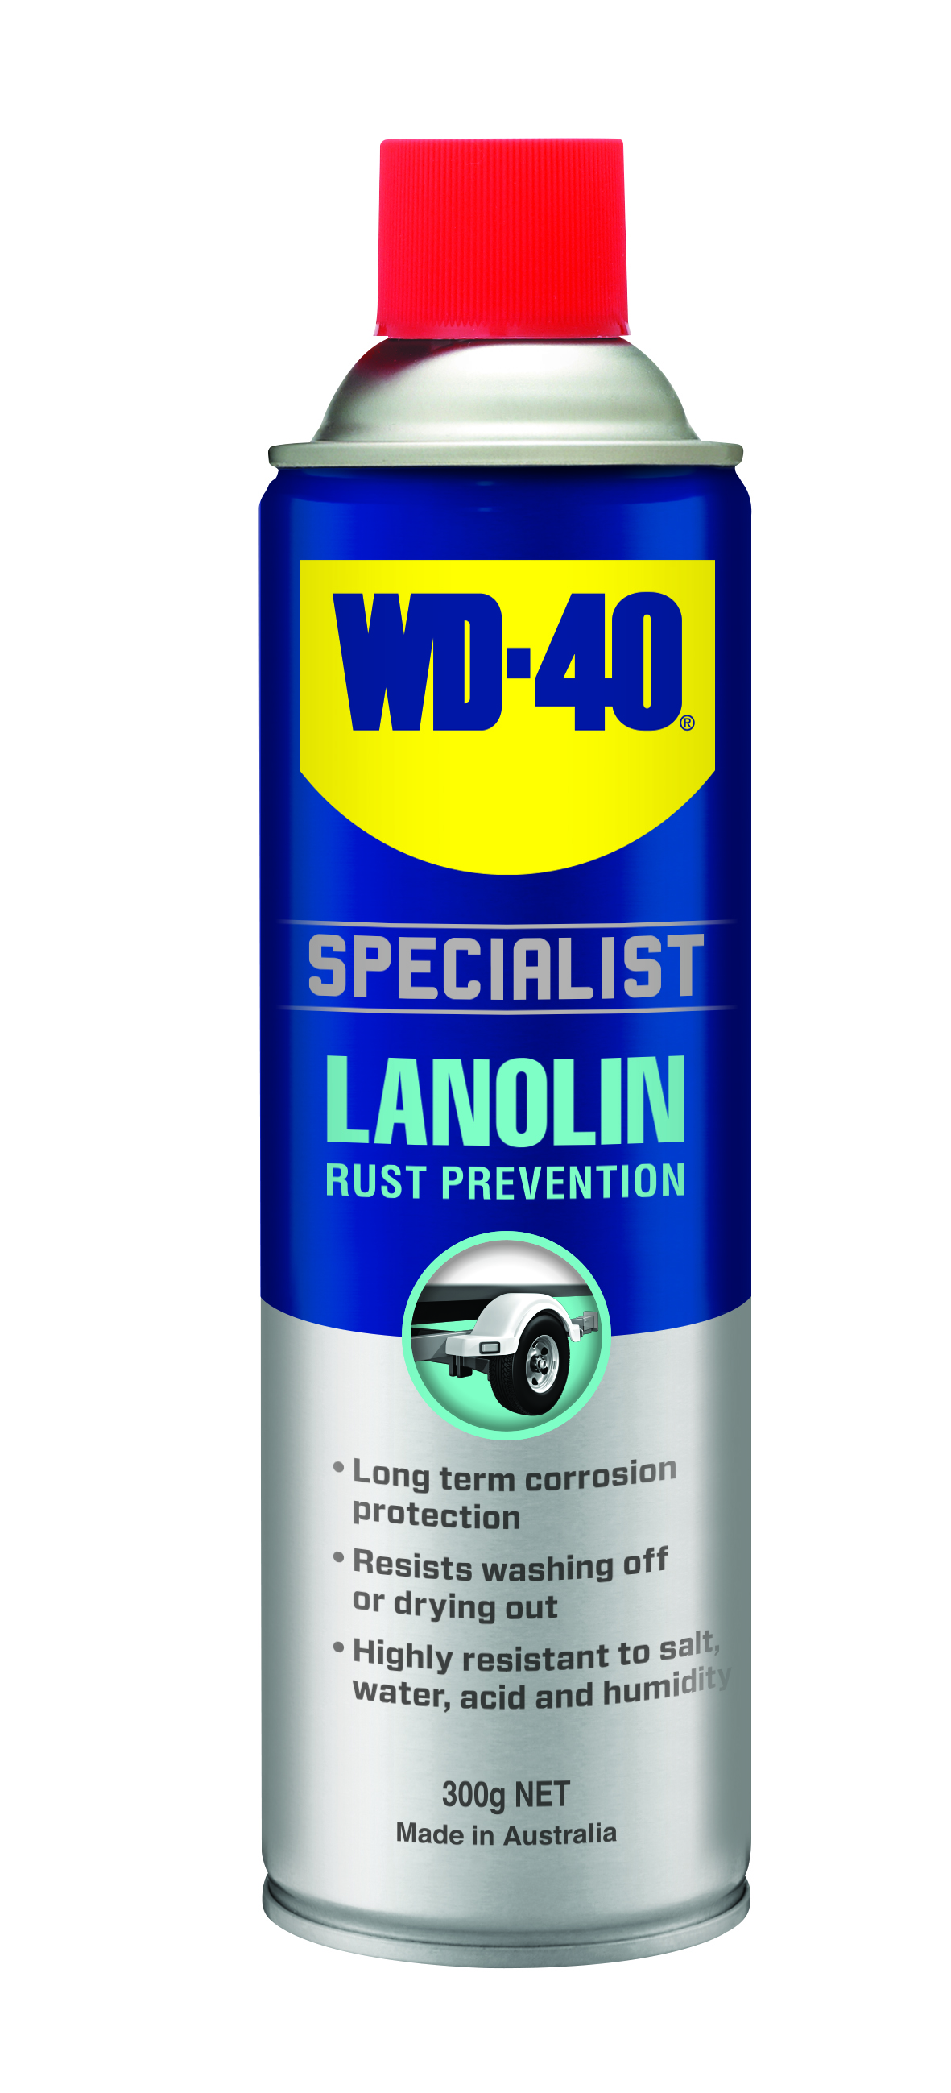
Applications | Features & Benefits
- Tow Bars  - Car Underbodies  - Leaf Springs  - Metal Gear  - Trailers  - Farm Equipment  - Marine Equipment | - Long term corrosion protection  - Resists wash off  - Resistant to salty, humid, and acidic environments
Fluid Properties

Packaging Specifications
SKU Codes and Description |  |  | Individual Item (Consumer Unit) |  |  |  |  | Carton (Traded Unit) |  |  |  |  |  | Pallet Information
Case Codes | Unit Codes | Product Description | Dimensions (mm) |  |  | Cubic Volume (cm³) | Gross Weight (kg) | Dimensions (mm) |  |  | Cubic Volume (cm³) | Gross Weight (kg) | Units  Per  Carton | Consumer Units Per Pallet | Dimensions (mm) |  |  | Gross Weight (kg)
Case Codes | Unit Codes | Product Description | Width | Depth | Height | Cubic Volume (cm³) | Gross Weight (kg) | Width | Depth | Height |  |  |  |  | Width | Depth | Height | Gross Weight (kg)
21121 | 21024 | WD-40 Specialist Rust Prevention Lanolin Lubricant 300g | 66 | 66 | 240 | 1045.4 | 0.4 | 137 | 200 | 245 | 6710 | 2.51 | 6 | 1200 | 1165 | 1165 | 1375 | 536

Directions
Shake can well. Ensure surface is clean and dry before application. Spray directly on area to be lubricated ensuring full coverage for maximum protection. Repeat if necessary.


TECHNICAL DATA SHEET

WD-40 Specialist®
Lanolin

Hazard identification
HAZARDOUS SUBSTANCE. DANGEROUS GOODS. According to the WHS Regulations and the ADG Code.
DANGER! Extremely flammable aerosol. Pressurized container: may burst if heated. May be fatal if swallowed and enters airways. Repeated exposure may cause skin dryness or cracking. Keep away from heat, hot surfaces, sparks, open flames and other ignition sources. No smoking. Do not spray on an open flame or other ignition source. Do not pierce or burn, even after use. If swallowed: Immediately call a POISON CENTER or doctor. DO NOT induce vomiting. If discomfort persists, see a doctor. Additional information is listed in the safety data sheet.
Storage
Store in a cool, dry, well- ventilated area away from incompatible materials. Protect from physical damage. Do not store in direct sunlight, near open flames or above temperatures greater than 50°C.
Regulatory Information
Montreal Protocol (Ozone Depleting Substances): None present. The Stockholm Convention (Persistent Organic Pollutants): None present. The Rotterdam Convention (Prior Informed Consent): Not applicable. Basel Convention: Not applicable. International Convention for the Prevention of Pollution from Ships (MARPOL): Not applicable. Standard for the Uniform Scheduling of Medicines and Poisons (SUSMP): Not applicable

Australian Inventory of Chemical Substances: All the components of this product are listed on the AICS inventory
New Zealand Inventory: All the ingredients comply with the HSNO regulations

Level 2, 41 Rawson Street, Epping, NSW 2121 Australia Version: 1.0
wd40.com.au

