BOILING POINT (INITIAL): | 100°C | SPECIFIC GRAVITY: | 0.99 typical at 21°C
SOLUBILITY IN WATER: | Miscible | pH: | 11
VAPOR PRESSURE: | Not determined | VAPOR DENSITY: | >1
PERCENT VOLATILE: | Not determined | VOC: | 21%
COEFFICIENT OF WATER/OIL DISTRIBUTION: | Not determined | APPEARANCE/ODOR: | Light amber liquid with citrus odor
FLASHPOINT: | Not determined | FLAMMABLE LIMITS: | LEL 1.8% UEL 9.5%


TECHNICAL DATA SHEET

WD-40 Specialist®
Degreaser

Product Description |  | PACKAGING
WD-40 Specialist Degreaser Fast Acting Citrus consists of D-limonene, a powerful solution with release agent function which prevents adhesion of unwanted residue. The powerful foam works immediately on contact and is easy to rinse with water. For use on multiple surfaces including uncoated metal, exhaust hoods and flooring. |  | 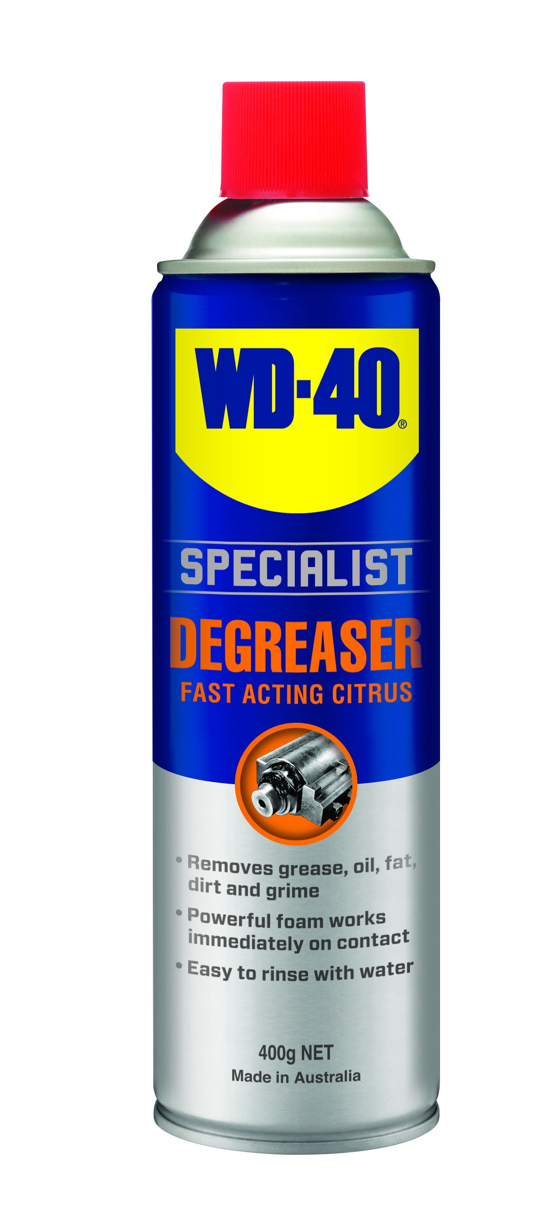
Applications | Features & Benefits
- Wastewater plumbing & grease traps  - Automotive equipment  - Tools  - Marine equipment  - Machinery | - Removes grease, oil, fat, dirt & grime  - Powerful foam works immediately on contact  - Easy to rinse with water  - Powerful formula designed to lift engine grease and carbon deposits
FLUid Properties

Packaging Specifications
SKU Codes and Description |  |  | Individual Item (Consumer Unit) |  |  |  |  | Carton (Traded Unit) |  |  |  |  |  | Pallet Information
Case Codes | Unit Codes | Product Description | Dimensions (mm) |  |  | Cubic Volume (cm³) | Gross Weight (kg) | Dimensions (mm) |  |  | Cubic Volume (cm³) | Gross Weight (kg) | Units  Per  Carton | Consumer Units Per Pallet | Dimensions (mm) |  |  | Gross Weight (kg)
Case Codes | Unit Codes | Product Description | Width | Depth | Height | Cubic Volume (cm³) | Gross Weight (kg) | Width | Depth | Height |  |  |  |  | Width | Depth | Height | Gross Weight (kg)
91101 | 91001 | WD-40 Specialist Lawn & Garden Powerful Foaming Cleaner 400g | 66 | 66 | 239 | 1041 | 0.525 | 137 | 204 | 253 | 7071 | 3.26 | 6 | 1200 | 1165 | 1165 | 1415 | 686

Directions
Shake can well. Spray liberally on surface to be cleaned. Allow to penetrate for 30 seconds before agitating with a brush or cloth. Wipe off any excess liquid. Repeat as necessary. Always test on a small inconspicuous area first.

* Avoid prolonged contact with rubber and DO NOT use on painted or powder-coated surfaces.

TECHNICAL DATA SHEET

WD-40 Specialist®
Degreaser

hazard identification
HAZARDOUS SUBSTANCE. DANGEROUS GOODS. According to the WHS Regulations and the ADG Code.
DANGER! Extremely flammable aerosol. Pressurized container: may burst if heated. Causes skin irritation. May cause an allergic skin reaction. Causes serious eye irritation. Toxic to aquatic life with long lasting effects. Keep away from heat, hot surfaces, sparks, open flames and other ignition sources. No smoking. Do not spray on an open flame or other ignition source. Do not pierce or burn, even after use. Avoid breathing mist or vapors. Wash thoroughly after handling. Contaminated work clothing should not be allowed out of the workplace. Avoid release to the environment. Wear protective gloves and eye protection. If in eyes: Rinse cautiously with water for several minutes. Remove contact lenses, if present and easy to do. Continue rinsing. If on skin: wash with plenty of soap and water. Take off contaminated clothing and wash before reuse. If discomfort persists, see a doctor. Additional information is listed in the safety data sheet.
Storage
Store in a cool, dry, ventilated area away from incompatible materials. Protect from physical damage. Do not store in direct sunlight, near open flames or above temperatures greater than 50°C.

Regulatory Information
Montreal Protocol (Ozone Depleting Substances): None present. The Stockholm Convention (Persistent Organic Pollutants): None present. The Rotterdam Convention (Prior Informed Consent): Not applicable. Basel Convention: Not applicable. International Convention for the Prevention of Pollution from Ships (MARPOL): D-Limonene (as Depentene) is listed. Standard for the Uniform Scheduling of Medicines and Poisons (SUSMP): Not applicable

Australian Inventory of Chemical Substances: All the components of this product are listed on the AICS inventory
New Zealand Inventory: All the ingredients comply with the HSNO regulations


Level 2, 41 Rawson Street, Epping, NSW 2121 Australia Version: 1.0
wd40.com.au

TECHNICAL DATA SHEET

