BOILING POINT (INITIAL): | 60°C | SPECIFIC GRAVITY: | 0.66 typical at 15°C
SOLUBILITY IN WATER: | Insoluble | pH: | Not applicable
VAPOR PRESSURE: | 25kPa at 20°C | RELATIVE VAPOR DENSITY: | 3.0
PERCENT VOLATILE: | Not determined | VOC: | >90%
COEFFICIENT OF WATER/OIL DISTRIBUTION: | Not determined | APPEARANCE/ODOR: | Colorless liquid with a strong petroleum odor
FLASHPOINT: | -33°C | FLAMMABLE LIMITS: | LEL: 1.2 UEL: 7  (Isohexane)
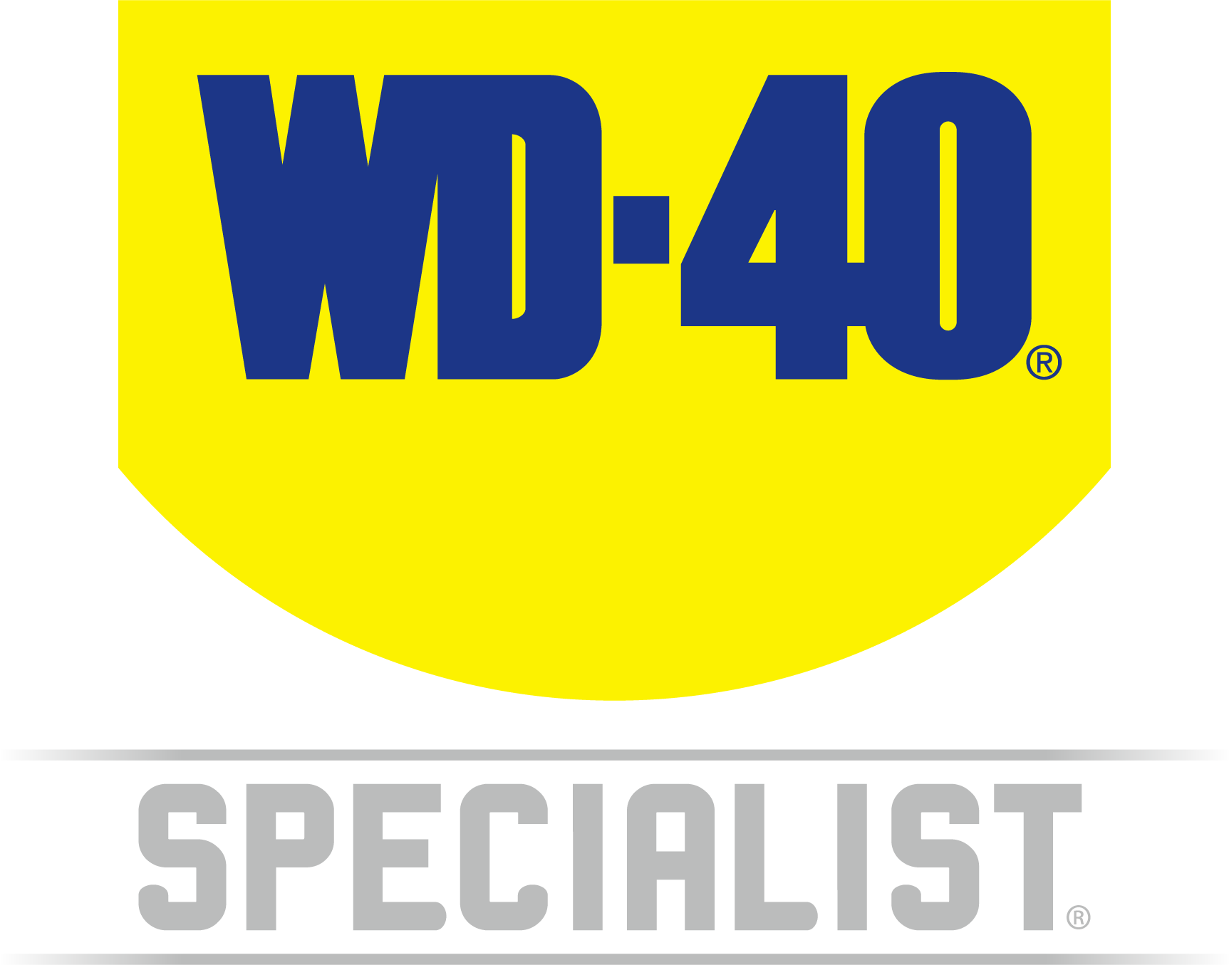

TECHNICAL DATA SHEET

WD-40 Specialist®
CONTACT CLEANER

Product Description |  | PACKAGING
WD-40 Specialist Contact Cleaner blasts away oil, dirt, flux reside and condensation from sensitive electronics and electrical equipment. It rapidly penetrates into hard-to-reach areas and dries quickly, without leaving any residue and removes oil and dirt, making it the best at cleaning electrical contacts. Safe and ideal for use on electrical equipment such as printed circuit boards, contacts, controls, battery terminals, switches, precision instruments and electric panels. |  | 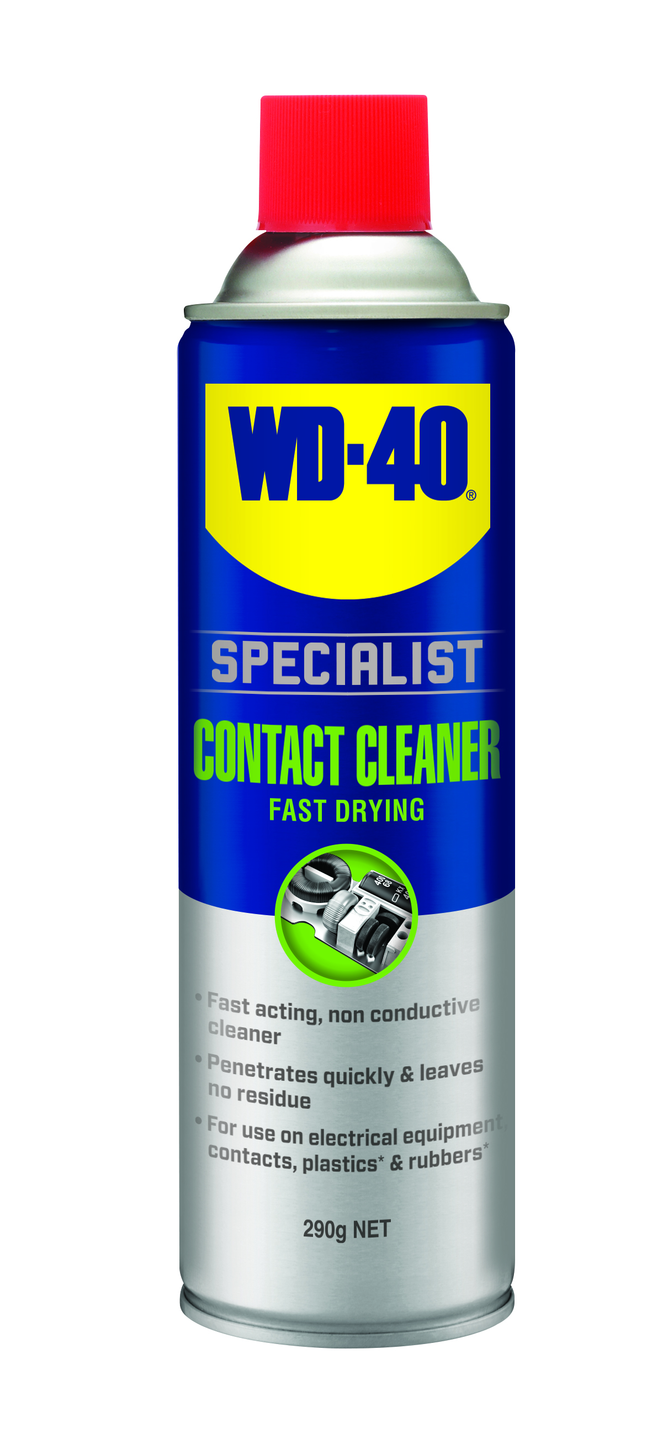
Applications | Features & Benefits
- Printed Circuit Boards  - Controls  - Switches  - Tape Heads  - Precision Instruments | - Fast acting, Non-conductive Cleaner  - Cleans Sensitive Electronic Equipment  - Penetrates Quickly & Leaves No Residue  - Plastic* & Metal Safe  - Quick Drying  * Always test on an inconspicuous area before use.
Fluid Properties

Packaging Specifications
SKU Codes and Description |  |  | Individual Item (Consumer Unit) |  |  |  |  | Carton (Traded Unit) |  |  |  |  |  | Pallet Information
Case Codes | Unit Codes | Product Description | Dimensions (mm) |  |  | Cubic Volume (cm³) | Gross Weight (kg) | Dimensions (mm) |  |  | Cubic Volume (cm³) | Gross Weight (kg) | Units  Per  Carton | Consumer Units Per Pallet | Dimensions (mm) |  |  | Gross Weight (kg)
Case Codes | Unit Codes | Product Description | Width | Depth | Height | Cubic Volume (cm³) | Gross Weight (kg) | Width | Depth | Height |  |  |  |  | Width | Depth | Height | Gross Weight (kg)
21104 | 21004 | WD-40 Specialist Fast Drying Contact Cleaner 290g | 66 | 66 | 239 | 1041 | 0.425 | 137 | 270 | 255.7 | 9458.3 | 2.7 | 6 | 1008 | 1165 | 1165 | 1173 | 487.6

Directions
Isolate all power & allow any hot surfaces to cool. Make sure all stored power Is drained from the system. Shake can well. Spray directly onto the electronic device or circuit board to eliminate and remove any contaminants that may cause loss of electrical contact. Tilt surface while cleaning and allow any excess cleaner to run off. Allow product to dry completely and thoroughly. Vent the system before restoring power.

hazard identification
HAZARDOUS SUBSTANCE. DANGEROUS GOODS. According to the WHS Regulations and the ADG Code.
DANGER! Extremely flammable aerosol. Pressurized container: may burst if heated. May be fatal if swallowed and enters airways. Causes skin irritation. May cause drowsiness or dizziness. Toxic to aquatic life with long lasting effects. Keep away from heat, hot surfaces, sparks, open flames and other ignition sources. No smoking. Do not spray on an open flame or other ignition source. Do not pierce or burn, even after use. Avoid breathing mist or vapors. Wash thoroughly after handling. Use only outdoors or in a well-ventilated area. Avoid release to the environment. Wear protective gloves. If swallowed: Immediately call a POISON CENTER or doctor. DO NOT induce vomiting. If on skin: wash with plenty of soap and water. If skin Irritation occurs: get medical attention. Take off contaminated clothing and wash It before reuse. If inhaled: Remove person to fresh air and keep comfortable for breathing. If discomfort persists, see a doctor. Additional information is listed in the safety data sheet.

Storage
Store in a cool, dry ventilated area away from incompatible materials. Protect from physical damage. Do not store in direct sunlight, near open flames or above temperatures greater than 50°C.
Regulatory Information
Montreal Protocol (Ozone Depleting Substances): None present. The Stockholm Convention (Persistent Organic Pollutants): None present. The Rotterdam Convention (Prior Informed Consent): Not applicable. Basel Convention: Not applicable. International Convention for the Prevention of Pollution from Ships (MARPOL): Not applicable. Standard for the Uniform Scheduling of Medicines and Poisons (SUSMP): Not applicable

Australian Inventory of Chemical Substances: All the components of this product are listed on the AICS inventory
New Zealand Inventory: All the ingredients comply with the HSNO regulations


WD-40 Specialist®
Contact Cleaner

TECHNICAL DATA SHEET

Level 2, 41 Rawson Street, Epping, NSW 2121 Australia Version: 1.0
wd40.com.au

