BOILING POINT (INITIAL): | 90-104°C | SPECIFIC GRAVITY: | 0.76 typical at 25°C
SOLUBILITY IN WATER: | Insoluble | pH: | Not applicable
VAPOR PRESSURE: | Not determined | VAPOR DENSITY: | >1
PERCENT VOLATILE: | Not determined | VOC: | Not determined
COEFFICIENT OF WATER/OIL DISTRIBUTION: | Not determined | APPEARANCE/ODOR: | Clear liquid with a mild petroleum/ solvent odor
FLASHPOINT: | -8°C | FLAMMABLE LIMITS: | LEL: 0.7% UEL: 6.7%


WD-40 Specialist®
Chain Lube

TECHNICAL DATA SHEET

Product Description |  | PACKAGING
WD-40 Specialist Chain Lube penetrates all parts of the chain and leaves a complete coating, providing long-lasting lubrication and protection for chains from wear and moisture, and O, X and Z ring compatible. High performance and extremely tacky chain lubricant which is suitable for street and off-road motorcycle, kart and ATV application. Quick-drying and provides outstanding anti-fling properties. |  | 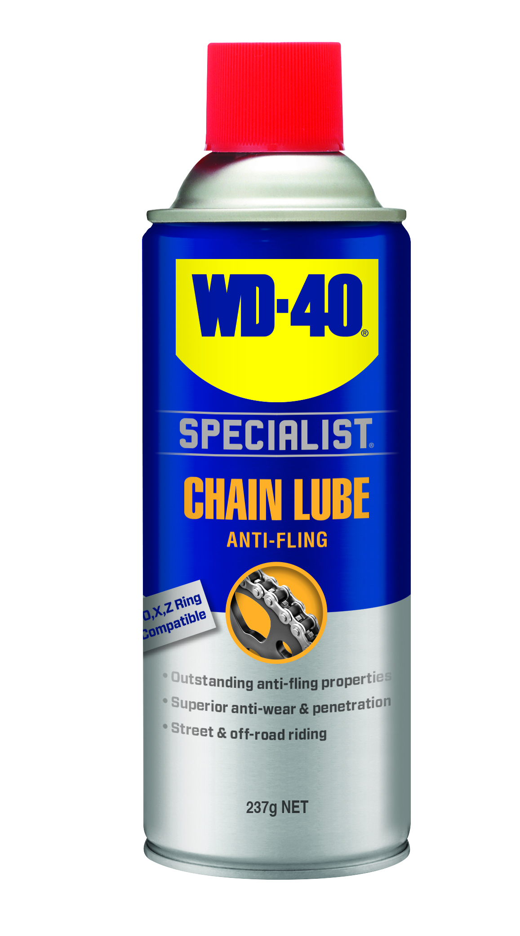
Applications | Features & Benefits
- Drive Chains  - Drivertrain  - Street Bikes  - 4WD Vehicles | - Compatible with O, X and Z rings  - Quick drying  - Outstanding anti-fling properties  - Superior anti-wear & penetration  - Long lasting  - Suitable for street and off-road riding
fluid Properties

Packaging Specifications
SKU Codes and Description |  |  | Individual Item (Consumer Unit) |  |  |  |  | Carton (Traded Unit) |  |  |  |  |  | Pallet Information
Case Codes | Unit Codes | Product Description | Dimensions (mm) |  |  | Cubic Volume (cm³) | Gross Weight (kg) | Dimensions (mm) |  |  | Cubic Volume (cm³) | Gross Weight (kg) | Units  Per  Carton | Consumer Units Per Pallet | Dimensions (mm) |  |  | Gross Weight (kg)
Case Codes | Unit Codes | Product Description | Width | Depth | Height | Cubic Volume (cm³) | Gross Weight (kg) | Width | Depth | Height |  |  |  |  | Width | Depth | Height | Gross Weight (kg)
21127 | 21030 | WD-40 Specialist Chain Lube 237g | 66 | 66 | 204 | 888.6 | 0.34 | 135 | 201 | 205 | 5562.6 | 2.15 | 6 | 1200 | 1165 | 1165 | 1175 | 464

Directions
Before spraying: clean chain to remove dirt, oil and grime. SHAKE CAN WELL before EACH spray. Apply to full length of inside of chain and allow lubricant to run vertically down into chain parts. Leave to dry.


Hazard identification
TECHNICAL DATA SHEET

WD-40 Specialist®
Chain Lube

HAZARDOUS SUBSTANCE. DANGEROUS GOODS. According to the WHS Regulations and the ADG Code.
DANGER! Extremely flammable aerosol. Pressurized container: may burst if heated. May be fatal if swallowed and enters airways. Causes skin irritation. May cause an allergic skin reaction. May cause drowsiness or dizziness. Very toxic to aquatic life with long lasting effects. Keep away from heat, hot surfaces, sparks, open flames and other ignition sources. No smoking. Do not spray on an open flame or other ignition source. Do not pierce or burn, even after use. Avoid breathing mist or vapors. Wash thoroughly after handling. Use only outdoors or in a well-ventilated area. Contaminated work clothing should not be allowed out of the workplace. Avoid release to the environment. Wear protective gloves and eye protection. If swallowed: Immediately call a POISON CENTER or doctor. DO NOT induce vomiting. If on skin: Wash with plenty of soap and water. Take off contaminated clothing and wash it before reuse. If inhaled: Remove person to fresh air and keep comfortable for breathing. If discomfort persists, see a doctor. Additional information is listed in the safety data sheet.
Storage
Store in a cool, dry, well- ventilated area away from incompatible materials. Protect from physical damage. Do not store in direct sunlight, near open flames or above temperatures greater than 50°C.
Regulatory Information
Montreal Protocol (Ozone Depleting Substances): None present. The Stockholm Convention (Persistent Organic Pollutants): None present. The Rotterdam Convention (Prior Informed Consent): Not applicable. Basel Convention: Not applicable. International Convention for the Prevention of Pollution from Ships (MARPOL): Not applicable. Standard for the Uniform Scheduling of Medicines and Poisons (SUSMP): Not applicable

Australian Inventory of Chemical Substances: All the components of this product are listed on the AICS inventory
New Zealand Inventory: All the ingredients comply with the HSNO regulations.
Level 2, 41 Rawson Street, Epping, NSW 2121 Australia Version: 1.0
wd40.com.au

