BOILING POINT (INITIAL): | 82.4°C | SPECIFIC GRAVITY: | 0.79 typical at 21°C
SOLUBILITY IN WATER: | Immiscible | pH: | Not applicable
VAPOR PRESSURE: | Not determined | VAPOR DENSITY: | Not determined
PERCENT VOLATILE: | Not determined | VOC: | Not determined
COEFFICIENT OF WATER/OIL DISTRIBUTION: | Not determined | APPEARANCE/ODOR: | Clear colorless liquid with a solvent odor
FLASHPOINT: | 12°C | FLAMMABLE LIMITS: | LEL 0.6% UEL 12.0%
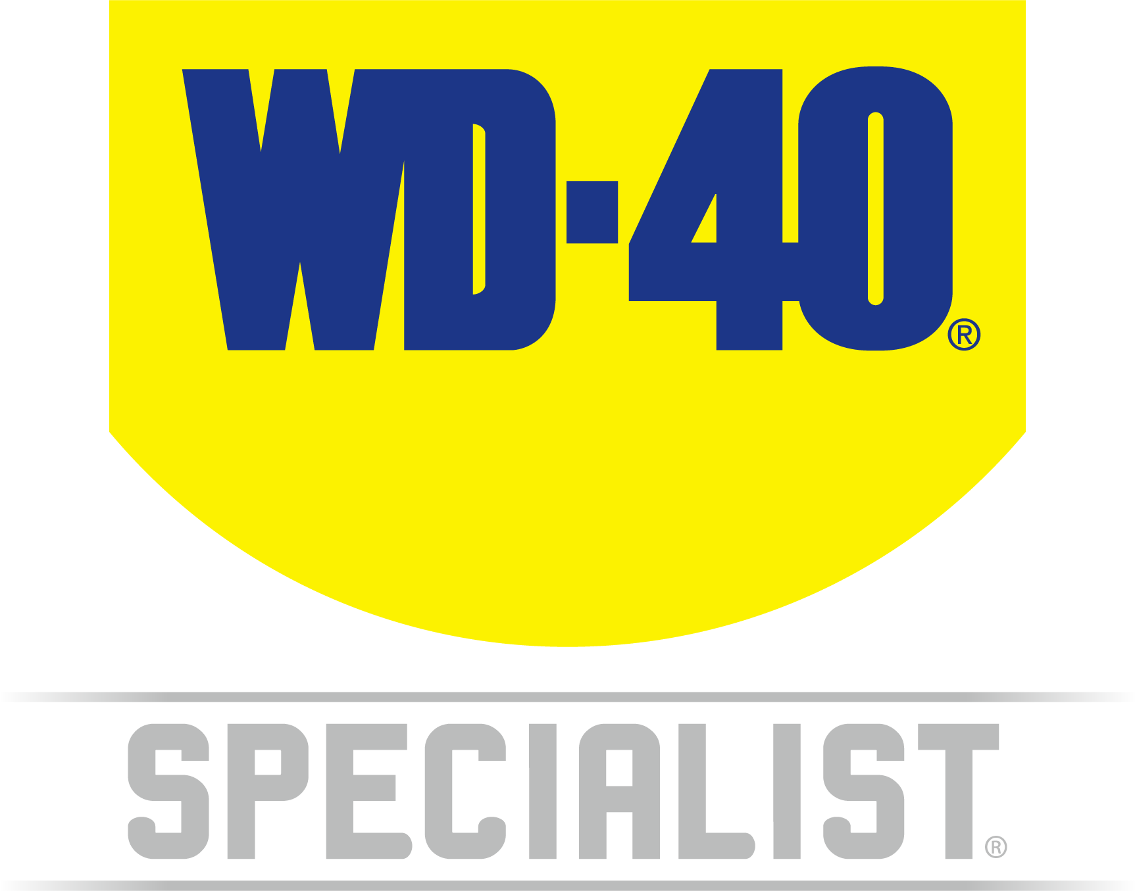

WD-40 Specialist®
BRAKE & PARTS CLEANER

TECHNICAL DATA SHEET

Product Description |  | PACKAGING
This WD-40 Specialist Automotive Brake & Parts Cleaner quickly removes brake fluid, grease, oil and other contaminants on disc brakes, brake lining, pads, drums, and calipers. it cleans without disassembling the brake unit, is non-staining, leaves no residue and is non-corrosive. Just spray generously on the whole unit. It cleans to help stop disc brake squeal and eliminate clutch slippage. |  | 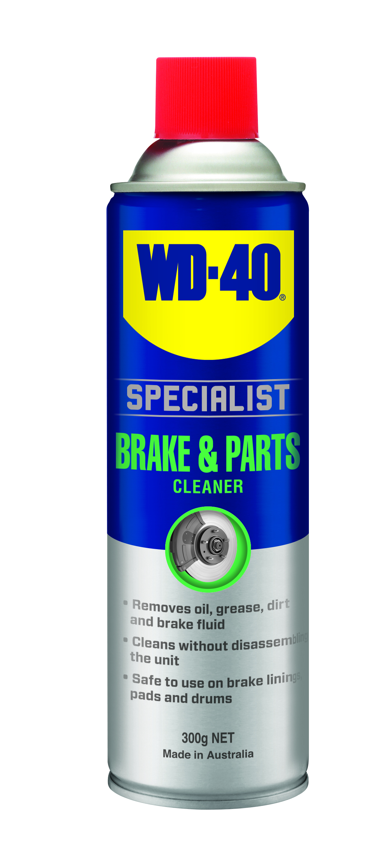
Applications | Features & Benefits
- Brake Discs  - Brake Pads  - Brake Drums  - Metal Car Parts | - Formulated for rapid & safe removal of brake fluid, grease, oil & other contaminants on disc brake  - Removes oil, grease, dirt & brake fluid  - Cleans without disassembling the unit  - Safe to use on brake linings, pads & drums
fluid Properties

Packaging Specifications
SKU Codes and Description |  |  | Individual Item (Consumer Unit) |  |  |  |  | Carton (Traded Unit) |  |  |  |  |  | Pallet Information
Case Codes | Unit Codes | Product Description | Dimensions (mm) |  |  | Cubic Volume (cm³) | Gross Weight (kg) | Dimensions (mm) |  |  | Cubic Volume (cm³) | Gross Weight (kg) | Units  Per  Carton | Consumer Units Per Pallet | Dimensions (mm) |  |  | Gross Weight (kg)
Case Codes | Unit Codes | Product Description | Width | Depth | Height | Cubic Volume (cm³) | Gross Weight (kg) | Width | Depth | Height |  |  |  |  | Width | Depth | Height | Gross Weight (kg)
21116 | 21019 | WD-40 Specialist Brake & Parts Cleaner 300g | 66 | 66 | 245 | 1067 | 0.43 | 137 | 200 | 245 | 6713 | 2.68 | 6 | 1200 | 1165 | 1165 | 1375 | 570

Directions
SHAKE CAN WELL. Spray parts generously to remove brake fluid, grease, oil & other contaminants. Dry with a soft cloth, then allow to air dry. Repeat application if necessary. DO NOT spray on hot running engines. DO NOT use on painted surfaces. Prolonged exposure to rubber & plastic not recommended. Consult manufacturer's instruction before use.

hazard identification
HAZARDOUS SUBSTANCE. DANGEROUS GOODS. According to the WHS Regulations and the ADG Code.
DANGER! Extremely flammable aerosol. Pressurized container: may burst if heated. May be fatal if swallowed and enters airways. Causes serious eye irritation. May cause drowsiness or dizziness. Harmful to aquatic life with long lasting effects. Repeated exposure may cause skin dryness or cracking. Keep away from heat, hot surfaces, sparks, open flames and other ignition sources. No smoking. Do not spray on an open flame or other ignition source. Do not pierce or burn, even after use. Avoid breathing mist or vapors. Wash thoroughly after handling. Use only outdoors or in a well-ventilated area. Avoid release to the environment. Wear eye protection. If in eyes: Rinse cautiously with water for several minutes. Remove contact lenses, if present and easy to do. Continue rinsing. If inhaled: Remove person to fresh air and keep comfortable for breathing. If swallowed: Immediately call a POISON CENTER or doctor. DO NOT induce vomiting. If discomfort persists, see a doctor. Additional information is listed in the safety data sheet.
Storage
Store in a cool, dry, ventilated area away from incompatible materials. Protect from physical damage. Do not store in direct sunlight, near open flames or above temperatures greater than 50°C.
Regulatory Information
Montreal Protocol (Ozone Depleting Substances): None present. The Stockholm Convention (Persistent Organic Pollutants): None present. The Rotterdam Convention (Prior Informed Consent): Not applicable. Basel Convention: Not applicable. International Convention for the Prevention of Pollution from Ships (MARPOL): Not applicable. Standard for the Uniform Scheduling of Medicines and Poisons (SUSMP): Not applicable

Australian Inventory of Chemical Substances: All the components of this product are listed on the AICS inventory
New Zealand Inventory: All the ingredients comply with the HSNO regulations


Level 2, 41 Rawson Street, Epping, NSW 2121 Australia Version: 1.0
wd40.com.au

WD-40 Specialist®
Brake and Parts Cleaner

TECHNICAL DATA SHEET

